Quality Control (QC) Appendix
Visit 10
Version 2.0 - 2/21/2023

Table of Contents
A. General Summary and Timeline Documents 2
Appendix QC1. Summary of Observation and Equipment Checklists 3
Appendix QC2. Timeline for Observation and Equipment Checks 5
Appendix QC3. Minimum Frequency of Procedures and Interviews to Maintain Data Quality 6
B. Observation Checklists 7
Appendix QC4. Checklist for Observation of Interviewing Technique 8
Appendix QC5. Checklist for Observation of Anthropometry Measurement 9
Appendix QC6. Checklist for Observation of Blood Pressure Measurements 11
Appendix QC7. Checklist for Observation of Physical Function 12
C. Calibration and Maintenance Logs 14
Appendix QC8. Anthropometry Equipment Calibration Log 15
Appendix QC9. OMRON BP Monitor Maintenance and Calibration Log 16
Appendix QC10. Audiometry Calibration Log 17
Appendix QC11. Sample of Adverse Events and Unanticipated Problems Sa 19

General Summary and Timeline Documents

Summary of Observation and Equipment Checklists

Instructions: This form should be completed quarterly and sent to the Coordinating Center (CC) within two weeks of the end of the quarter.

FIELD CENTER |  | DATE: //  Month Day Year

Quarterly reporting period | Jan-Mar 20 Apr-Jun 20 Jul-Sept 20 Oct-Dec 20

- Observation Checklist
 |  | Technician ID | Supervisor ID | Date (mm/dd/yy)
General interview techniques

Anthropometry
Sitting blood pressure
Biospecimen collection
Physical Function

B. Equipment Checklist
 | Frequency | No. times assessed | No. times within calibration
Anthropometry
1) Scale read zero | Daily
2) Weight scales* | Weekly
Blood Pressure
1) Checks for the OMRON BP machine  (Provide for each machine being used) | Quarterly
Physical Function
1) Grip strength dynamometer | Bi-Annually
Biospecimen collection
1) Refrigerators, freezers, room temp | Daily
2) Speed of centrifuge | Annually
Audiology
1) All audiometric equipment calibrated | Annually
2) Interacoustic Equinox 2.0 audiometer checked for functionality | Daily
3) ShoeBox audiometer checked for functionality | Daily
4) Optional Bioacoustic Simulator calibration completed on the Interacoustic Equinox 2.0 audiometer and the ShoeBox audiometer | Weekly
Zeno Gait Mat
1) Checks for the mat, including sensors, clicker fob, starting line, and placement | Daily
Comments: _________________________________________________________________
___________________________________________________________________________
*Home visit scales should also be calibrated

Timeline for Observation and Equipment Checks

Daily | Anthropometry scales balanced to read zero (Appendix QC8)  Temperature check in refrigerators, freezers, etc. (Manual 7)  All audiology equipment should undergo daily Functional Checks, including checking for regular wear and tear, proper connections, and quick listening checks for functionality. (Manual 22)
Weekly | Anthropometry scales calibrated or when scales moved. Home visit scales should also be calibrated weekly (Appendix QC5)  Optional: Interacoustic Equinox 2.0 audiometer and ShoeBox audiometer should be checked using the Bioacoustics Simulator and/or undergo a biologic check for accuracy (Manual 22)
Quarterly | Summary of anthropometry technicians recorded (Appendix QC1)  Summary of anthropometry equipment checks (Appendix QC1)  Blood pressure technicians observed (Appendix QC6), recorded (Appendix QC1)  OMRON BP equipment checks and calibration (Appendix QC9), summarized on (Appendix QC1)  Biospecimen collection, processing observed (Manual 7), recorded (Appendix QC1)  Biospecimen equipment checks summarized, info sent to CC (Appendix QC1)  Physical function technicians observed (Appendix QC7), recorded (Appendix QC1)
Bi-Annually | Anthropometry technicians observed study coordinator twice monthly for the first month following certification and then twice per year observed (Appendix QC5)  Grip strength dynamometer calibrated (Manual 32)
Annually | Checking of the actual speed of the centrifuge (Appendix QC1)  Calibration and professional cleaning of pipettes (Appendix QC1)  All audiology equipment calibrated (Manual 22)

Minimum Frequency of Procedures and Interviews to Maintain Data Quality

Procedure  (and associated forms) | Min. # / Month | Min. # / Month
 | Primary Technicians | Designated  Back-up Techs
Anthropometry (ANT) | 6 | 2
Blood collection & processing (BIO) | 4 | 4
Seated BP (SBP) | 4 | 2
Physical Function and Activity (PAC, PFX, TME, TMW, ZGM) | 4 | 2
Medication Survey (MSR) | 4 | 2
Audiology (HHI, HNES, AUD) | 5 | 2
CES Depression (CES) | 2 | 1

Observation Checklists

Checklist for Observation of Interviewing Technique

ADMINISTRATIVE INFORMATION
0a. Completion Date: // 0b. Supervisor ID:
Month Day Year
0c. Interviewer ID:
Proficiency in Interview technique Yes No Comments
1. Introduces her/himself at beginning of the interview. ______________
2. Thanks participant at the end of the interview. ______________
3. Explains purpose of interview when appropriate, ______________
e.g., reads introductions or transition statements
when included on form.
4. States questions exactly as written, stressing ______________
time frame and key elements.
5. Demonstrates familiarity with content, flow, ______________
definitions, and skip patterns.
6. Uses standardized tone of voice with ______________
supportive, non-judgmental statements.
7. Paces interview in response to participant’s ______________
level of comprehension/comfort.
8. Trains participant in response patterns when ______________
appropriate.
9. Refrains from probing except to clarify ______________
ambiguous, unclear, or inconsistent responses.
10. Uses standardized definitions when asked for ______________
clarification.
11. Repeats questions stressing portions of ______________
question which were misunderstood.
12. Interviewer demonstrates knowledge of _____________
participant’s tracing information.
13. Selects appropriate type of probe. ______________
14. Accurately records participant’s responses. ______________
15. Comments: __________________________________________________________________
_______________________________________________________________________________________

Checklist for Observation of Anthropometry Measurement

Instructions: This checklist documents observation of anthropometry technicians by supervisors. Quarterly checklists and logs are summarized onto the Summary of Observation and Equipment Checklists (Appendix 1).

TECH ID NUMBER: |  |  |  | SUPERVISOR ID NUMBER: |  |  |  | DATE: //  Month Day Year
Yes No Comments
1. Anthropometry is done BEFORE the snack. ____ _ __
2. If the participant is wearing any nylon hose other
than knee highs, the participant is instructed to
remove hose. ____ _ __
3. Participant is wearing light-weight, non-constricting
underwear. ____ _ __
4. Participant is wearing a light clothes or scrub suit. ____ ____ __
5. Participant has removed shoes. ____ ____ __
6. Participant has emptied bladder. ____ _ _ __

Weight Measurement Yes No Comments
A. Equipment
1. Scale firm on floor. ____ ____ __
2. 10 kg standard weight available. ____ ____ __
3. Anthropometry Equipment Calibration log up-to-date. ____ ____ __

B. Procedure
1. Participant prepared and procedure explained. ____ ____ __
2. Participant is bare-foot. ____ ____ __
3. Position of participant on center of scale. ____ ____ __
4. Balance achieved. ____ ____ __
5. Recordings completed. ____ ____ __
Technician’s measurement of participant weight: _________ kg
Supervisor’s measurement of participant weight: _________ kg

Waist Measurement Yes No Comments
1. Procedure is explained to participant. ____ ____ __
2. Subject stands erect, yet relaxed, with weight
equally distributed on both feet, and feet together. ____ ____ __
3. Place the tape horizontally at the level of the
umbilicus (navel). ____ ____ __
4. Subject takes a normal breath and gently exhales,
holding breath in a relaxed manner at the end of
exhalation. ____ ____ __
5. Tape is horizontal and snug, but not tight enough
to compress tissue. [Invert tape, if needed, to insure ____ ____ __
reading edge of tape is snug to skin for measurement.]
6. Reading is recorded to the nearest centimeter,
rounding down. ____ ____ __
Technician’s measurement of participant waist: _________ cm
Supervisor’s measurement of participant waist: _________ cm

Comments: _______________________________________________________
_________________________________________________________________
_________________________________________________________________

Checklist for Observation of Blood Pressure Measurements
Instructions: This checklist documents observation of technicians certified to perform blood pressure by supervisors. Quarterly checklists and logs are summarized onto the Summary of Observation and Equipment Checklists (Appendix 1).

TECH ID NUMBER: |  |  |  | SUPERVISOR ID NUMBER: |  |  |  | DATE: //  Month Day Year
Blood Pressure Measurement Yes No Comments
1. Checks function settings on OMRON unit
(ENTER, 3 inflations, 30)
2. Checks Mode and P-setting on OMRON unit
3. Makes sure AC adapter for OMRON unit is
securely connected (tends disconnect from unit)
4. Checks AC adapter cord and tubing for cracks
5. Cleans all the equipment
6. Allows subject to rest for five full minutes
7. Performs arm measurement and cuff selection
properly
8. Identified brachial pulse location properly
9. Proper cuff placement
10. Attaches cuff to monitor
11. Uses proper settings on OMRON unit
12. Turns monitor on with ON/OFF button
13. Sets MODE selector to AVG
14. Sets P-SET knob to AUTO
15. Pushes START button
16. Records 1st, 2nd, 3rd systolic and diastolic BP
readings and average heart rate
17. Instructions to participant are clear
18. Holds arm vertically for 5 seconds between readings
19. Informs participant of average readings
Comments: _______________________________________________________
_________________________________________________________________

Checklist for Observation of Physical Function
Instructions: This checklist documents observation of technicians responsible for physical function by the lead supervisor. Quarterly checklists and logs are summarized onto the Summary of Observation and Equipment Checklists (Appendix 1). Copies of this log may be requested by the CC.

TECH ID NUMBER: |  |  |  | SUPERVISOR ID NUMBER: |  |  |  | DATE: //  Month Day Year

Satisfactory/
Chair Stands Unsatisfactory Comments
1. Back of chair against a wall ___ ______________________
2. Script correctly and clearly delivered ___ ______________________
3. Correctly demonstrates single stand, ___ ______________________
emphasizing keeping arms tight across chest
4. Correctly demonstrates two stands, ___ ______________________
emphasizing full stand and return to complete
sit
5. Says “ready? Go” for each test ___ ______________________
6. Counts each chair stand and record final time ___ ______________________
when participant comes to a full standing
position on the fifth stand
7. Records and explains unusual values ___ ______________________
8. If task was not performed, codes and explains ___ ______________________
reasons
Standing Balance/Side-by-side Stand
1. Script correctly and clearly delivered ___ ______________________
2. Correctly demonstrates position ___ ______________________
3. Timing started coincident with participant ___ ______________________
release and stopped when participant takes
a step or holds on
4. If task was not performed, codes and explains ___ ______________________
reasons
Semi-tandem Stand
1. Script correctly and clearly delivered ___ ______________________
2. Correctly demonstrates position ___ ______________________
3. Timing started coincident with participant ___ ______________________
release and stopped when participant takes
a step or holds on
4. If task was not performed, codes and explains ___ ______________________
reasons
Tandem Stand
1. Script correctly and clearly delivered ___ ______________________
2. Correctly demonstrates position ___ ______________________
3. Timing started coincident with participant ___ ______________________
release and stopped when participant takes
a step or holds on
4. If task was not performed, codes and explains ___ ______________________
reasons
5. Repeats second trial, if necessary ___ ______________________
Short Walks, Usual Pace
1. Script correctly and clearly delivered ___ ______________________
2. Correctly demonstrates ___ ______________________
3. Toes touching start line ___ ______________________
4. Clicker started on “Go” ___ ______________________
5. Time stopped when the first foot crosses ___ ______________________
imaginary plane extending vertically up from
the ending line/tape
6. Repeats second trial ___ ______________________
Grip Strength
1. Asked pt about recent surgery on hands ___ ______________________
2. Asked pt about pain and arthritis in hands ___ ______________________
3. Recording dial reset to zero after sub ___ ______________________
maximal practice
4. Appropriate hand placement and grip ___ ______________________
adjustment if needed
5. Forearm resting on table, elbow bent to ___ ______________________
approximate right angle
6. Standard encouragement (motivation and ___ ______________________
feedback) offered to participant
7. Recording dial (peak hold needle) reset to ___ ______________________
zero after first trial
Comments: ________________________________________________________________
__________________________________________________________________________
__________________________________________________________________________

Calibration and Maintenance Logs

Anthropometry Equipment Calibration Log
Instructions: This checklist documents the daily, weekly and monthly calibration of anthropometry measurement equipment. Quarterly checklists and logs are summarized onto the Summary of Observation and Equipment Checklists (Appendix 1). Copies of this log may be requested by the CC. There should be one such log done each week though the monthly portion will be filled out only in the weeks that it is needed. If there is more than one piece of equipment used for a particular function indicate the checks for each piece on the same log. Home visit scales should also be checked/calibrated weekly.

Week of:_____ Field Center: Tech ID:
[Monday’s Date]

Daily Checks:
Scales read zero ___ ___ ___ ___ ___ ___ ___
M T W Th F Sa Su

Weekly Checks
A. Reading of scale with 10 kg weight (if reading outside 9.5 to 10.5 range, scale should be serviced.
Date: ___/___/___ Reading: ______________
Date service REQUESTED, ____/____/____
Date RECALIBRATED by service technician. ____/____/____

B. Repeat calibration because of moving scales
Date: ____/____/____ Reading: ______________
Date: ____/____/____ Reading: ______________

OMRON BP Monitor Maintenance and Calibration Log

Instructions: This checklist documents the quarterly checks for the OMRON BP machine. There should be one such log done every quarter. If there is more than one BP monitor used indicate the checks with a separate log for each monitor. Quarterly checklists are summarized onto the Summary of Observation and Equipment Checklists (Appendix 1).

TECH ID NUMBER: |  |  |  | FIELD CENTER |  | DATE: //  Month Day Year

Blood Pressure Measurement OMRON unit #:__________
 | Y/N | If YES, action
Cracking
Holes
Worn outer cloth of Velcro
Leakage of cuff bladder
Calibration Check with Pressure-Vacuum Meter
Smooth descent of OMRON LED mm Hg from 280 to 20 mm Hg
Observed pressure values 250 to 20 mmHg, in approximant decrements of 20 mmHg | OMRON (mmHg) | Pressure-Vacuum Meter (mmHg)
Measurement Number 1 | . | . mmHg
Measurement Number 2 | . | . mmHg
Measurement Number 3 | . | . mmHg
Measurement Number 4 | . | . mmHg
Measurement Number 5 | . | . mmHg
Measurement Number 6 | . | . mmHg
Measurement Number 7 | . | . mmHg
Measurement Number 8 | . | . mmHg
Measurement Number 9 | . | . mmHg
Measurement Number 10 | . | . mmHg
Measurement Number 11 | . | . mmHg
Measurement Number 12 | . | . mmHg

Audiometry Calibration Log

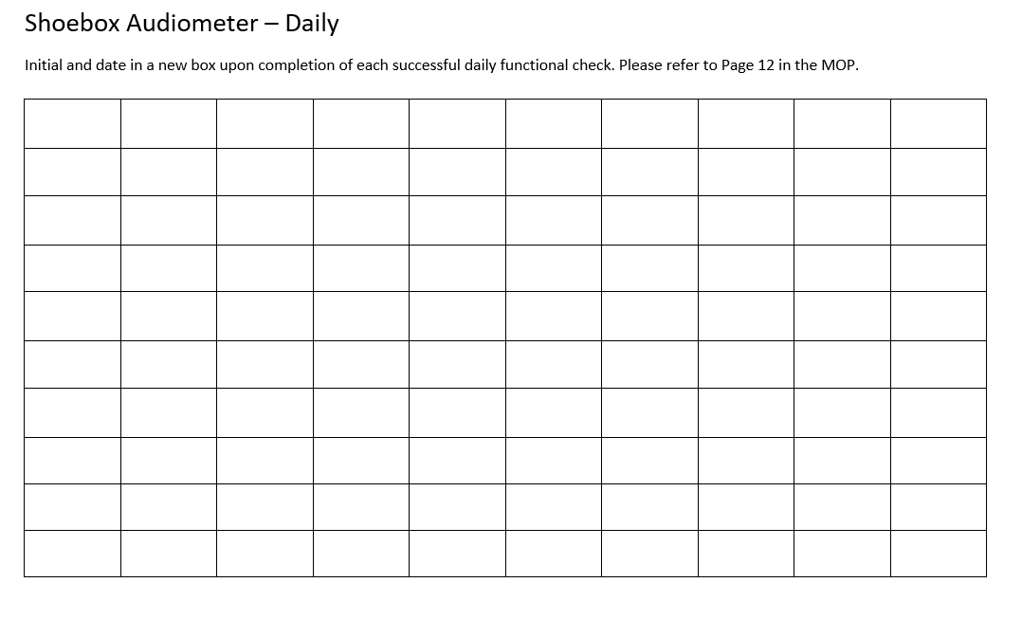
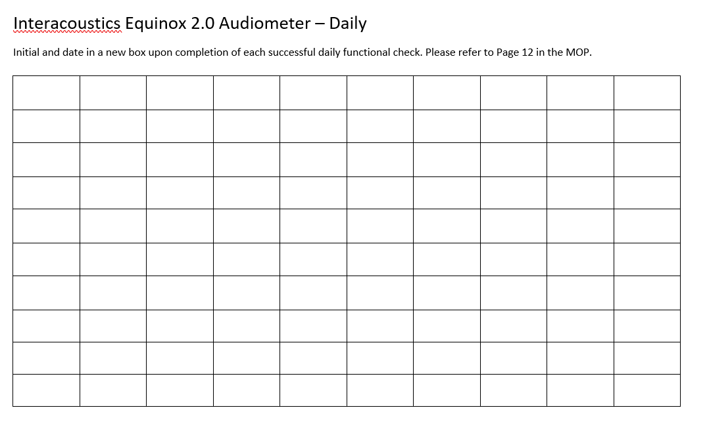
Instructions: These checklists document the daily functional checks for the Interacoustics Equinox 2.0 Audiometer and the Shoebox Audiometer. See Manual 22 for more information.
Instructions: These checklists document the optional weekly bioacoustics and biologic checks for the Interacoustics Equinox 2.0 Audiometer and the Shoebox Audiometer. See Manual 22 for more information.
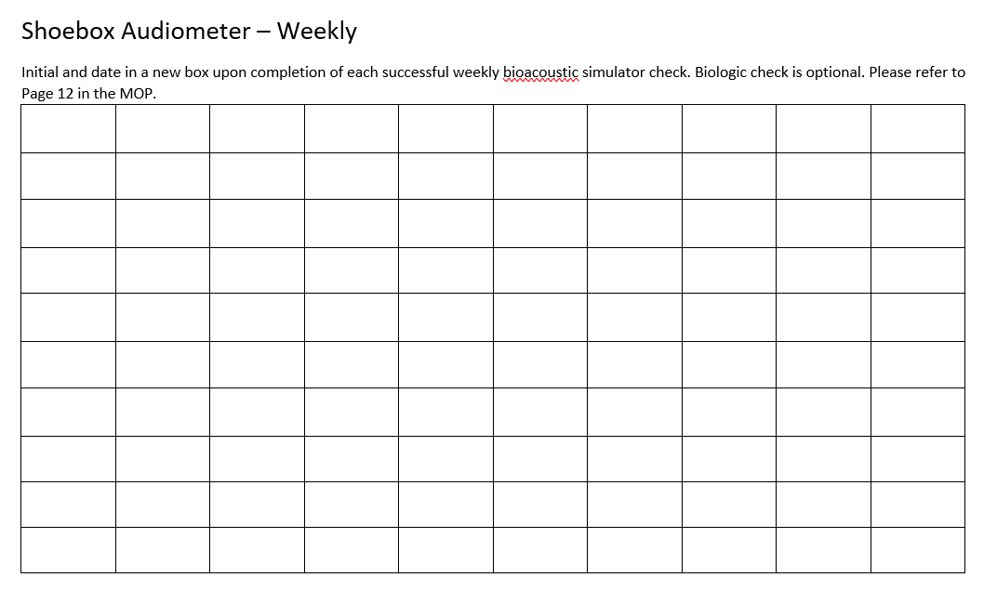
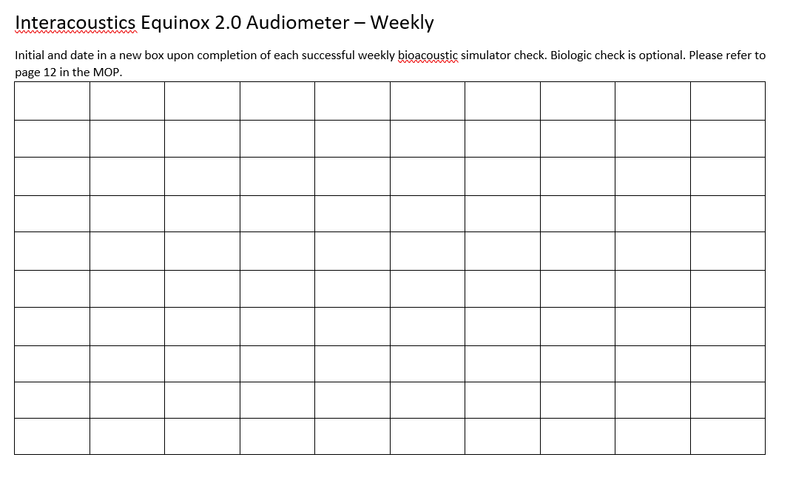

Sample of Adverse Events and Unanticipated Problems Sa

Sample of Adverse Events and Unanticipated Problems for Use in Calibration

XXXXXX on --/--/-- During the regular echocardiography scan the sonographer identified a “mobile vegetation". The ppt is asymptomatic. The study physician was contacted and the reading center was asked for an expedited report. The study physician recommended immediate follow up with the participant’s cardiologist or PCP. The ppt remained asymptomatic and was sent to the physician’s office via taxi. -- Follow-up (added the following day): Ppt was seen by a cardiologist, echocardiogram was repeated, not admitted. Spoke with ppt the next day, who reports doing well.
Circle One Action needed re. procedures or training?
Report as UP / SAE / MAE / Do not report |  | Follow-up needed?

XXXXXX < Date > The echo tech reported the participant asleep but unresponsive after completing the study echo. Breathing and heart rate were normal; skin was warm. The ppt. remained unresponsive for 2-3 minutes. The study MD was contacted and a 911 call was initiated. The EMS crew elicited a response, obtained a med hx and vital signs. The ppt. refused to be taken to the ER. AMA form signed. Ppt was escorted home in a cab by a member of the study staff. Study RN will follow up on < Date >
Report as UP / SAE / MAE / Do not report |  | Follow-up needed?

XXXXXX < Date > Participant called the field center to report experiencing severe nausea and feeling extremely hot after leaving the clinic the previous day. She initially thought this was due to a gastric problem and made an appointment to see her doctor. No significant findings were identified at the doctor’s office. The participant then felt that her symptoms are associated with participation in the ARIC exam visit. The case was reported to the PI and a ___ form was entered in CDART. Since the participant is now feeling well and had obtained medical evaluation the event is considered resolved. No further action was taken.
Report as UP / SAE / MAE / Do not report |  | Follow-up needed?

XXXXXX < Date > Immediately following removal of the electrode placed on the interior of the L arm for the echo procedure, the participant complained of pain. Skin irritation with blisters was observed at the site. An ice pack was applied to the area for 20 min; blisters had resorbed but the participant was left with reddened skin area of 1cm x 3.5 cm, and a burning sensation at this site.
Report as UP / SAE / MAE / Do not report |  | Follow-up needed?

XXXXXX - < Date > After the snack the participant was taken for the first set of neurocog. interviews. He started trembling, felt cold and anxious, no sweating, no nausea, no blurry vision. Vital signs were in the normal range and stable. The participant was placed lying down with legs elevated, covered with a blanket. His vital signs were monitored for 15 minutes until the trembling subsided and he felt calm and warm.
Report as UP / SAE / MAE / Do not report |  | Follow-up needed?

XXXXXX - < Date > 76 y/o male participant who is wheelchair bound following CVA one year ago. Ppt went to use toilet after snack, accompanied by home health aide. Ppt became unresponsive while sitting on toilet. Health aide called nursing staff for assistance. Ppt was transferred from toilet to wheelchair by staff and 911 was called. Ppt slowly became aware. The entire episode of unresponsiveness lasted about 2 mins.
EMS arrived about 15 mins later. Medical hx, ascertained from study visit given to EMS staff (hx significant for seizures, diabetes and asthma). EMS recommended transfer to xxxxxxxx medical center for further f/u. The ppt was transferred to the ER via ambulance, accompanied by home health aide. At the time of the transfer to the ER, ppt was alert and oriented, appeared cognitively intact and BP was 124/72.
Report as UP / SAE / MAE / Do not report |  | Follow-up needed?

XXXXXX - < Date > Sitting blood pressure recorded as 178/96. When rechecked during cardiac echo, BP was 216/106. Rechecked sitting blood pressure per protocol and found it to be 170/92 with a heart rate of 72. Participant took her medications with the snack, at the field center (benazepril 40 mg and amlodipine 5 mg). She has a follow up appointment with her PMD within the week; a report of her blood pressures was provided to her for review with the PCP. The participant was able to complete the exam visit without further incident
Report as UP / SAE / MAE / Do not report |  | Follow-up needed?

XXXXXX - < Date > Staff reported that the participant became emotional during administration of questionnaires. When engaged by the interviewer the participant mentioned feeling lonely. The study nurse spoke with participant and options for counseling/mental health services were discussed. The participant approved of ARIC staff assisting her in making an appointment with her PCP to discuss her feelings of sadness and a possible referral. Appt. made for __/__/__
Report as UP / SAE / MAE / Do not report |  | Follow-up needed?

XXXXXX - <Date > Assay results were transposed as a result of an incorrect transfer file format. The error was detected at the laboratory and the ARIC coordinating center was notified. By this time the study results had been mailed to this study participant. The assay result affected was the albumin-to-creatinine ratio. The assay values were in the normal range for both specimens, and the message provided to the study participant on account of these results did not differ between the new and old study results. A phone call was made to the study participant, who was then sent an updated set of results. Corrective actions were implemented at the ARIC coordinating center; no further action required by the field center.
Report as UP / SAE / MAE / Do not report |  | Follow-up needed?

XXXXXX – Date > On 1/30/17 the participant's husband called to notify staff (L.P.) that his wife's Ziopatch was removed early due to "hives". The study nurse (B.E.) called the participant on __/__/ to ask about the incident. The participant reported having itching within hours of the Ziopatch being placed, with a rash and hives developing as well. Due to this reaction, she removed the patch after wearing it for 7 days (as opposed to 14 days). She states that there was 1 hive underneath the patch and several around the patch. They had since "dried up" and scabbed over. The participant states that she has never had any reaction to any type of adhesive.
Report as UP / SAE / MAE / Do not report |  | Follow-up needed?

XXXXXX - < Date > Study participant stood up after completing the pulse wave velocity exam and sat in exam chair at 12:48. Peripheral neuropathy procedure was started at 12:50; approximately one minute later the study participant complained of dizziness. Peripheral neuropathy exam ceased and study nurse went to participant's side. The participant again stated that he felt hot and dizzy. At 12:54 the participant became unresponsive to verbal stimuli with a fixed gaze and was noted to be cool and clammy to the touch, and appeared lethargic. Vital signs were obtained and paramedics were summoned. At 13:00 participant stated that he felt better but was cool and clammy to the touch. 13:05 paramedics arrived and at 1320 participant was transported to local ER.
Report as UP / SAE / MAE / Do not report |  | Follow-up needed?

XXXXXX - < Date > While walking through the clinic to the lobby escorted by staff, the participant tripped over his cane and fell forward injuring the top of his right hand (skin tear), the underside of his left hand (skin tear) and his forehead above his right eye (scratch from his glasses). Participant denied any loss of consciousness, dizziness, or other illness (before or after fall), and said he believed that the fall was a result of him being clumsier than usual due to leg weakness - he insisted that he just tangled his legs up with his cane while walking.
Report as UP / SAE / MAE / Do not report |  | Follow-up needed?

XXXXXX - < Date > Ppt had a nice day with us and was not aware that anything was wrong until after she had gone home and woken up from an hour long nap and had pain in her left groin and front upper left leg. It hurts a great deal when she walks, but not when she sits or lies down. She waited a couple days then called to tell me. She wondered if it was from the ZioPatch or the ankle cuff, but the left groin is where the femoral ABI/PVW sensor is placed and where technicians probe with their fingers to locate the femoral pulse. She says the area is not red, or swollen, and there is no lump and at the time of the ABI test she was not aware of pressure on her groin area from the sensor. She appears to be familiar with the symptoms of a blood clot, but said several times that that was not the problem.
Report as UP / SAE / MAE / Do not report |  | Follow-up needed?

XXXXXX - < Date > Ppt and spouse came in for Visit 7 today. The (average) sitting blood pressure measurement was 207/070. Rechecked after 15min: 208/069. The participant reported she is on BP meds but did not take them today and does not have them with her. The exam was interrupted. When questioned, the participant stated she does have some headache. The participant agreed to see her physician and an appointment was made for the same day. During a follow-up call to the study participant on the next day the participant reported that her physician had modified her blood pressure medication, a follow-up appointment had been made, and that she was feeling well.
Report as UP / SAE / MAE / Do not report |  | Follow-up needed?

Note: For definition of events and reporting procedures, see MOP 2 section for Participant Safety.

