

Manual 22
Hearing Procedures
Visit 12
Version 1.6
September 5, 2025

Prepared by: Nicholas Reed, AuD, Clarice Myers, AuD, Jacqueline M Weycker, AuD

Materials in-part adapted from Council for Accreditation in Occupation Hearing Conservation and National Health and Nutrition Examination Survey materials


Hearing Procedures

Table of Contents
- CHAPTER 0: MOP REVISIONS SINCE VISIT 10 4
- CHAPTER 1: INTRODUCTION 5
Background and Rationale 5
Objective 5
Key Measures 5
Visit Overview 6
- CHAPTER 2: EQUIPMENT 7
Clinical Visit Room Set-up – Questionnaires 7
Clinical Visit Room Set-up – Audiometric Test Battery 7
Exterior of Booth 7
Interior of Booth 7
Home Visit Room Set-up 8
Required Equipment 8
Clinical Visit 8
Home Visit 10
Calibration 11
Annual Professional Calibration and Ambient Noise Monitoring 11
Weekly Calibration - Functional Check 11
Interacoustics Equinox 2.0 Audiometer and hearX Portable Audiometer 11
Optional Weekly Calibration – Bioacoustic Simulator 12
Interacoustic Equinox 2.0 Audiometer and hearX Portable Audiometer 12
Optional Calibration – Biologic Check 13
Interacoustics Equinox 2.0 Audiometer and hearX Portable Audiometer 13
Maintenance 14
General Care 14
Contacts 14
- CHAPTER 3: QUESTIONNAIRE PROTOCOL 16
Prior to Testing 16
General Instructions 16
Self-Reported Hearing and Noise Exposure Short Form (HNES) 16
Hearing Handicap Inventory for the Elderly-Screening (HHI) 17
- CHAPTER 4: CLINICAL VISIT AUDIOMETRY PROTOCOL 18
Prior to Testing 18
ACHIEVE-ARIC Visit Coordination and Equipment Use 18
Exam Room Preparation 18
Pure Tone Air Conduction Audiometry and QuickSIN Protocol 18
Needed Instrumentation 18
Pre-Audiometric Testing Procedure 19
Transducer (Headphone) Placement Procedure 19
Opening Software 21
Manual Hughson Westlake Testing 22
Considerations 26
Reinstruction 26
Difficult Situations 27
QuickSIN- Speech-In-Noise-Test 29
Controls for QuickSIN screen 30
Initial Set-up for QuickSIN administration 31
Procedure 33
Considerations 35
Results Reporting 36
- CHAPTER 5: HOME VISIT AUDIOMETRY PROTOCOL (hearX) 37
Prior to Testing 37
Room and Participant Preparation 37
Results Reporting 46
- CHAPTER 6: TRAINING AND CERTIFICATION 48

CHAPTER 0: MOP REVISIONS SINCE VISIT 10

Version Number | Date | Author | Section(s) | Description of Update
1.6 | 09/05/2025 | Sonia Guarda | All | The portable audiometer, hearX, is replacing the V10 Shoebox device. All references to Shoebox are replaced with hearX. (See Chapter 5.)  Otoscopy has been removed from the protocol.  Insert earphones will no longer be used in testing. All references to insert earphones have been replaced with phone or headphones.

CHAPTER 1: INTRODUCTION

Background and Rationale
Hearing loss prevalence nearly doubles with each age decade, and hearing loss becomes increasingly more severe with age. Age-related hearing loss has been independently associated with poorer cognitive, social, physical, and communicative functioning. It is hypothesized that hearing loss contributes to these poorer outcomes by increasing cognitive load, reducing social engagement, and through physical changes to brain structure/function (Figure 1). Alternatively, a shared pathologic process such as aging or microvascular disease could also contribute to these associations. These pathways are not mutually exclusive, and coexistent pathways could likely synergistically lead to impaired cognitive and physical functioning in older adults. By collecting hearing information within ARIC, we can explore hearing loss as a dependent and independent variable in relation to cardiovascular, neurocognitive, and quality of life measures.
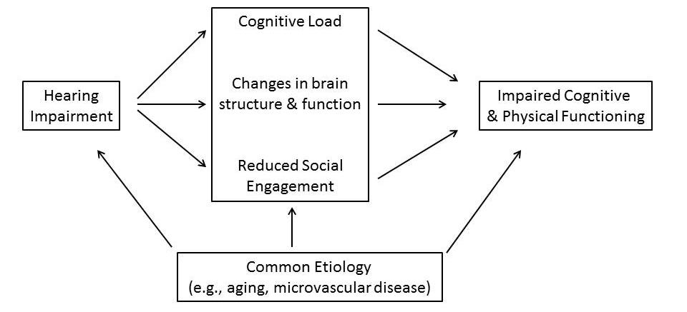
Figure 1. Proposed mechanisms of hearing impairment and poorer cognitive/physical functioning

Objective
This study will gather self-reported hearing loss information, pure-tone audiometry, and speech perception in a clinic-based sound-treated booth and/or with home-based testing equipment for those who cannot travel to the clinic. These data will provide both a quantitative and qualitative assessment of an individual’s hearing abilities and will allow us to investigate factors that lead to hearing loss and to understand the effects of hearing loss on the cognitive and physical functioning of older adults.

Key Measures
- Self-reported hearing ability
- Self-reported hearing aid use
- Hearing Handicap Inventory for the Elderly—Screening
- Pure-tone audiometry
- QuickSIN (speech-in-noise test)

Visit Overview
The hearing data collection visit can be conducted in the clinic or in the home of participants unable to commute to the ARIC clinic center. In the clinic, participants will complete two questionnaires and a full audiometric test battery. In the home, participants will complete two questionnaires but only a portion of the audiometric test battery. In both situations, the questionnaires should be administered prior to completing the audiometric testing.

CHAPTER 2: EQUIPMENT

Clinical Visit Room Set-up – Questionnaires
The questionnaires should be administered in a quiet room with a functioning door for privacy anywhere within the ARIC clinic. This room should contain a desk or table and at least two chairs for the technician and the participant. Chairs should be arranged so that the technician and participant are facing each other to ensure optimal communication conditions. Many of the ARIC sites have rooms already set up for ideal questionnaire administration.

Clinical Visit Room Set-up – Audiometric Test Battery
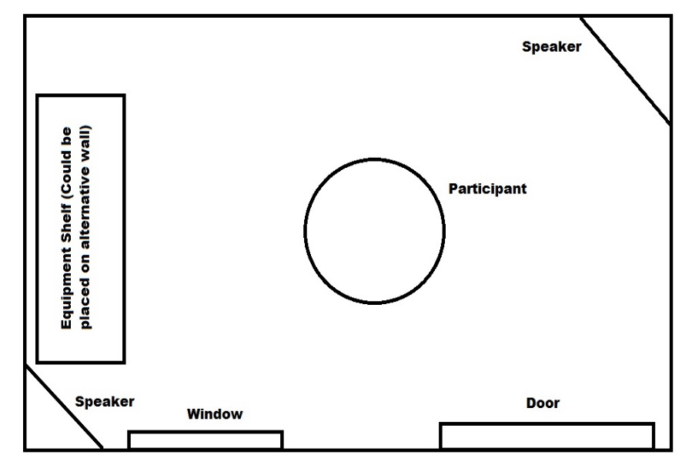
The majority of hearing testing will be conducted in a designated audiometry room. Each of the ARIC sites have identified rooms within their respective locations and have been provided with 7’ x 7’ whisper room sound booths. These booths are lightweight alternatives to the traditional sound booth and they provide sufficient ambient noise attenuation in combination with headphones to meet ANSI standards. The clinical visit set up should be similar to the diagram (Figure 2).

Figure . Interior Clinical Room Set Up
Note: In the event a sound booth is unavailable in the clinic, the hearX system that will be used in home visits may be used in a quiet testing room. Similarly, the hearX device may be used for data collection in the sound booth as well.

Exterior of Booth
The area outside the booth includes a small work area for the technician. A computer with the Interacoustics software should be set up on a table near the booth window so that the technician can see the participant in their chair in the WhisperRoom. The software will be installed and the computer should be linked with an audiometer during equipment installation by Interacoustics equipment dealer. Please note that the computer monitor and keyboard, along with the appropriate CRFs needed to record results, should be situated on the desk so that a participant in the booth cannot visualize them to prevent possible interference with testing (i.e., participants may be influenced by cues of seeing the technician’s hands moving).

Interior of Booth
Within the booth, a chair should be placed in the center of the room so that the participant is facing the speaker nearest the window that the technician will sit behind. In essence, the participant will be facing the technician through the window. A second speaker will sit directly behind the participant’s chair. The supra-aural headphones will be placed on the wall on hooks.

Home Visit Room Set-up
During the home visit, or in the event a sound booth is unavailable in the clinic, technicians will be required to find the most feasible space possible for testing; the space should be quiet. See home visit procedures for more information.

Required Equipment

Clinical Visit

- Sound attenuating audiometric test booth (WhisperRoom). The 7’x7’ modular sound attenuation booth will allow for hearing threshold testing with minimal ambient noise that may interfere with testing.
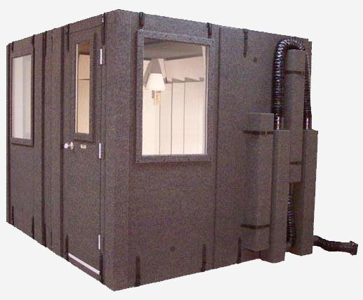
Figure . WhisperRoom Sound Booth

- Interacoustics Equinox 2.0 Diagnostic Audiometer with response button. This is a computer-based audiometer system that is used to obtain air conduction thresholds and QuickSIN data on all participants in the clinic setting. The audiometer works with DD450 headphones.
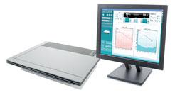
Figure 5. Interacoustics Equinox 2.0 Audiometer.

- DD450 Headphones. These headphones will deliver sound to the ear by sitting over the ear on the outside of the canal. In the clinic, these will be used when the eardrum is not completely visible.
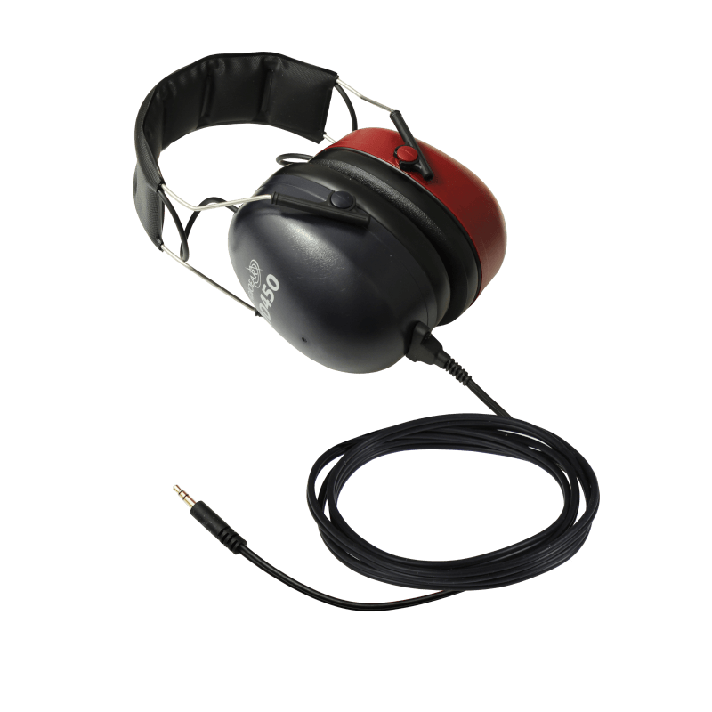
Figure 7. DD450 Headphones

- Audiologist’s Choice Audio Wipes. These wipes are used to clean ear covers of the supra aural headphones.
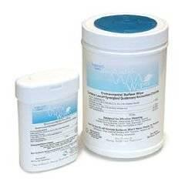
Figure 9. Audio Wipes

- Quest Model BA-202 Bioacoustic Simulator and accessories. The Quest Model BA-202 is a kind of “dummy” ear that is used to check the calibration of the audiometer daily. The simulator is programmed with 60 dB HL thresholds at each test frequency and its “hearing” should be tested every day to verify that the calibration of the audiometer has not shifted. Special adapters are provided to allow the simulator to be used with standard headphones.
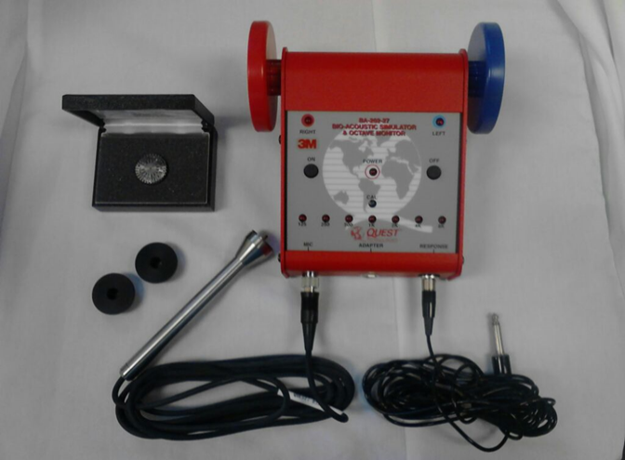

Response cable
Microphone
Pre-amp cable
Adaptors
for
inserts
Figure 10. Question Model BA-202 and accompanying accessories

Home Visit

- HearX Portable Audiometer (Samsung Tablet with hearX hearTest installed) with Calibrated HD 280 Pro Sennheiser Headphones. This Samsung device-based audiometer will be used for home visits and in the event a sound booth is unavailable in the clinic setting. It monitors ambient noise levels prior to and during testing to ensure reliable results. Only the HD 280 Pro headphones will accompany the equipment. (Please refer to Appendix C to review the hearX application set up)

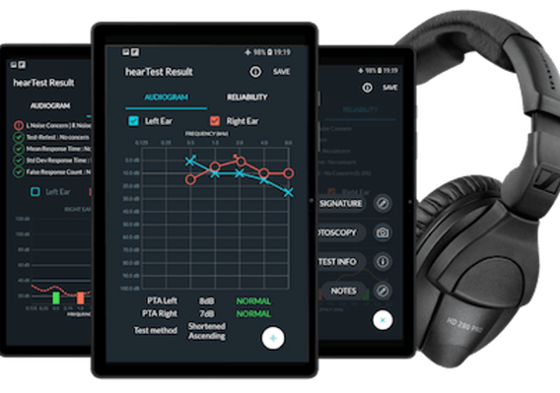

Figure 10. hearX Audiometer

Calibration

Annual Professional Calibration and Ambient Noise Monitoring
To ensure validity of data and compliance with ANSI standards, the clinic-based Interacoustics Equinox 2.0 Audiometer will be professionally calibrated annually by the local Interacoustics distributor. In addition, distributors will professionally evaluate the clinic sound environment during calibration visits. See maintenance section for contact information of each ARIC site’s local distributor.
For the home-based visits, hearX will calibrate HD 280 Pro headphones annually (approximately) as well as distribute software updates when necessary for the hearX portable audiometer system. Re-calibrated headphones will need to be reverified and linked to the hearX app on the Samsung device with which they will be used.
At the start of testing and whenever professional calibration is completed, technicians should test each other’s hearing to establish baselines for future Biologic Checks.
All calibration certificates should be stored in a binder along with a weekly calibration checklist.

Weekly Calibration - Functional Check
In addition to yearly calibrations, all equipment should be checked for a weekly “functional” calibration to ensure continual reliability of data.

Interacoustics Equinox 2.0 Audiometer and hearX Portable Audiometer
- Check the cords for signs of wear, cracking, or frayed wires
- Check the headphones for similar wear and cracking
- Check all connection ports for secure and tight insertion
- Conduct a listening check (Note: technician must have normal hearing to complete; it is acceptable to use a “good” ear in the case that a technician has hearing loss in only one ear but be sure to the adjust the headphones as needed)
  - Functional Check Objective
    - To verify that the unit is functioning properly and that the test signals are being generated and routed to the appropriate earphone without distortion, extraneous sounds (such as clicks or hum), or loss of signal. A listening check is conducted at the beginning of each testing day on the headphones.
  - To Complete for Interacoustics Equinox:
    - Open and setup the audiometer as if you are about to run a participant (see below) and start with the right ear
    - Set the volume level to 15 dB HL and the frequency to 500 Hz
    - Gradually increase volume to 50 dB HL. Listen to the tone pulses; verify that tones are clear and that there is no noticeable click or distortion at the beginning or end of each pulse.
    - Cycle through the rest of the test frequencies, repeating the step of increasing from 15 to 50 dB HL
    - Repeat the procedure for the left ear
  - To Complete for hearX:
    - Open the device and continue to the Pre-Test Screen (see below)
    - Select Practice Test
    - Set the volume level to 15 dB HL and the frequency to 500 Hz
    - Gradually increase volume to 50 dB HL. Listen to the tone pulses; verify that tones are clear and that there is no noticeable click or distortion at the beginning or end of each pulse.
    - Cycle through the rest of the test frequencies, repeating the step of increasing from 15 to 50 dB HL
    - Repeat the procedure for the left ear
  - Don’t Forget!
    - Wiggle the headphone cords when listening to ensure this does not create a short or intermittent signal
    - Use the response button during listening check to ensure its functionality
    - Change the stimulus across frequencies and vary the decibel level to ensure frequency (i.e., pitch) and intensity (i.e., volume) changes correspond appropriately
    - Make sure sound is coming out of where you are telling the audiometer to send it (i.e., if right headphone is selected, no sound should come from the left side)
- Record the completion of weekly calibration in the binder (Appendix A).
Please contact your local Interacoustic distributor OR Clarice Myers (clarice.myers@hearxgroup.com ) immediately in the case of malfunctioning equipment.

Optional Weekly Calibration – Bioacoustic Simulator

Interacoustic Equinox 2.0 Audiometer and hearX Portable Audiometer
At the beginning of the week, the Equinox Audiometer and hearX Portable Audiometer calibrations should be checked using the Bioacoustic Simulator (Quest BA 202). The bioacoustic check serves to confirm that the audiometer is remaining within the limits of calibration. This is done by testing someone (or something) with known hearing thresholds and verifying that the thresholds remain constant across time. The Bioacoustic Simulator serves as that “something” with known hearing levels. The simulator is programmed with a reference audiogram, which should remain unchanged if the calibration of the audiometer does not shift. The results of these checks are compared with the reference thresholds to verify that there has been no shift. Note, using the Bioacoustic Simulator for weekly calibrations is optional as long as sites are completing the daily Functional Checks.
The Quest BA-202-27 Bioacoustic Simulator is used to monitor the calibration of the right and left earphones of the standard headset.
- Headphones Check:
  - Ensure the Audiometer is on and setup as such
    - 250 Hz at 30 dB HL
    - Headset selected
    - Right ear selected
    - _∏_ and _∏_ _∏_ MUST NOT be selected (these are pulsed tones; calibration must be completed in continuous tones)
    - Man is selected
  - Position the BA-202 in the chair so that it is visible through the window
  - Place the headphones over the BA-202 so that the right (red) is over the red side and left (blue) is over the blue side
  - Leave this set up alone in the booth with the door closed
  - Slowly turn the left dB HL knob on the audiometer to increase the intensity in 5 dB steps. Pause a few seconds at each new intensity level and check to see if the right light on the simulator becomes illuminated (the response light on the audiometer should light up at the same time). Once the right light is lit, stop increasing the intensity and record the value on the audiometer in the binder
  - Advance to the next frequency (500 Hz) and return the audiometer to 30 dB HL
  - Repeat the step of slowly increasing the intensity until the BA-202 lights up and record the value
  - Repeat this at all frequencies for the right ear
  - Repeat procedures for the left ear
  - Remember to record values
- In the case of any change of >5 dB HL from previous recordings, please test that frequency again to ensure the change is repeatable, continue with testing of participants but please alert Clarice Myers (clarice.myers@hearxgroup.com).

Optional Calibration – Biologic Check
In the case that a BA-202 check is not available or in the case when results from BA-202 are questionable, a Biologic Check can be completed. Note that following calibration, participants should test their own hearing to establish baselines. A Biologic Check is similar to the BA-202 except it relies on technicians testing their own hearing to ensure similar results test to test. This check assumes that technicians’ hearing has not changed between tests.

Interacoustics Equinox 2.0 Audiometer and hearX Portable Audiometer
During the first week of testing or after professional calibration, baseline audiometric testing should be complete and stored on multiple ARIC staff members. From thereon out, on a weekly basis, technicians should complete a human subject Biologic Check. This is accomplished by testing the hearing of an individual staff member with known hearing thresholds and comparing them with the individual's baseline. It is recommended that biologic subjects not be at the lower limits of the audiometer. Choose subjects whose hearing thresholds are 15 dB HL or more above the lower limit (Note: the lower limit of the Interacoustics Equinox is -10 dB HL and the lower limit of the hearX Audiometer is 0 dB HL) of the audiometer to detect outputs, which increase. Subjects must have a known, stable hearing level; consequently, it is preferable to utilize a subject with normal hearing. A <15 dB change in test results at any test frequency (500-6000 Hz) is considered within normal test measurement variability.
A > 15 dB change indicates either an equipment malfunction or a change in hearing sensitivity of the individual. If this occurs, the biological calibration is repeated on a second individual to determine if the change is due to equipment malfunction or a change in hearing sensitivity of the first individual. At least two biologic subjects’ baseline hearing tests should always be retained for calibration purposes. Both biologic subjects should be used regularly during testing periods. Avoid using one subject regularly and intermittent use of the second subject.
If repeated > 15 dB calibrations occur for both biological test subjects, the audiometer must be professionally calibrated and repaired if necessary. Do not utilize equipment pending re-calibration and/or repair.
Record the completion of daily calibration in the binder (Appendix A).
Please contact your local Interacoustic distributor OR Clarice Myers (clarice.myers@hearxgroup.com) immediately in the case of malfunctioning equipment.

Maintenance

General Care
- Avoid placing instruments near significant heat sources and avoid ANY liquids on/near the equipment
- Equipment should be stored in cool, dry location within the provided case
- Should equipment be contaminated, it can be cleaned with a dry microfiber cloth and approved electronic cleaning solutions (Audiologist’s Choice Audio Wipes, pictured above). Please avoid organic solvents and/or aromatic oils
- Ensure that the Samsung Device is fully charged prior to testing each participant
- Clean equipment and space daily and between participants to ensure sanitary standards
  - Clean headphones with Audio Wipes between participants (regardless of contaminations) to maintain sanitary standards
- PDF Versions of Interacoustic Equipment manuals are located on desktop integrated with audiometer (downloaded during installation)

Contacts
In case of equipment issues, please contact your local Interacoustics distributor as well as one of the Johns Hopkins team members.
Hagerstown, MD ARIC Site:
e3 Kimmetrics-Bioacoustics, TJ Baust, thbs@biocoustics.com, 800-366-4616
Jackson, MS ARIC Site:
e3 Med-Acoustics, Gregory Ollick, goll@med-acoustics.com, 404-985-3219
Minneapolis, MN ARIC Site:
Midwest Special Instruments, Matt Williams, matt@midwestsi.com, 952-230-6353
Winston-Salem, NC ARIC Site:
e3 Carolinas Sales and Services, Joey Bair, joeybair@carolinassalesandservice.com, 800-776-9046
Johns Hopkins Team:
Nicholas Reed, Nicholas.Reed@nyulangone.org 317-694-2488
Clarice Myers, clarice.myers@hearxgroup.com, 806-676-7811
Jennifer Deal, jdeal1@jhu.edu, 410.502.3115
Jacqueline Weycker, weyck002@umn.edu, 612-626-5163

CHAPTER 3: QUESTIONNAIRE PROTOCOL
These questionnaires (HHI and HNES) will be administered in both the clinic-based and home-based visits. They will be administered prior to the Audiometry protocol (AUD).

Prior to Testing
- Ensure the room is relatively quiet and encourage the participant to wear any hearing devices they may regularly use.
- Ensure the participant is seated across from the technician so that they can see technician’s face for visual communication cues.
- Express to the participant that all information will be kept private.

General Instructions
- Please read questions verbatim.
- Speak clearly and at a normal, businesslike pace so that participants can fully understand questions without extending the time needed to administer the questionnaire by constantly repeating the questions.
- Have participants read questions when they have trouble following oral exam administration.
- Consider modifying the pace if the participant shows frustration and/or a lack of understanding (i.e., slow down pace and increase volume of voice if necessary) or if the participant shows annoyance and consistently jumps ahead (i.e., increase pace of questions to match their pace).
- Have a relaxed and friendly manner.
- Maintain a neutral, but conversational, tone when asking questions. Please attempt to sound natural and enthusiastic about the questions regardless of how many times one has already asked the questions (i.e., it is difficult to consistently administer the same questionnaire but please avoid sounding robotic in questioning).
- Maintain a neutral response to participants’ answers – do not indicate any reaction (e.g., surprise, disapproval).
- A short break is discouraged but may be necessary if the participant becomes fatigued.
- No questions should be skipped during the form. Please be familiar with all questions prior to administering the questionnaire.
- If the participant displays difficulty answering the question, first repeat the question for the participant and review response options before encouraging them to take their best guess for how it applies to them.
- Minimize missing data as much as possible by encouraging the participant to respond with their best guess or most appropriate answer if they respond, “I don’t know”.

Self-Reported Hearing and Noise Exposure Short Form (HNES)
All questions on this form are multiple choice and should be selected using a check mark in the appropriate box.
Some answers will trigger skipping ahead in questioning. For example, question 2 “Do you currently use a hearing aid or other device in your right ear?” has three possible answers: ‘No’, ‘Yes’, or ‘Other’. If ‘No’ is selected then question 3 and 4 are skipped while if ‘Yes’ is selected then 3 and 4 are administered as they directly relate to question 2. Please keep this potential pattern in mind as the form is completed. Please be familiar with all questions prior to administering the questionnaire.
- Begin with the following instructions: I am going to ask you a series of questions with mostly multiple-choice answers about your hearing. I will read you the question and the list of answers. Please wait until all answers have been read aloud before answering. Please select the most appropriate answer for you. Please let me know if you do not understand the question or could not hear me and I will re-read it and let you read it. As always, all of your answers are kept confidential. Do you have any questions before we begin? Answer any participant questions and continue.
- Read each statement to the participant
- For each question, check the box that corresponds to the answer the participant provides on the HNES CRF (Response Form). Some questions allow for multiple responses, please score according to the question.

Hearing Handicap Inventory for the Elderly-Screening (HHI)
All questions on this form are multiple choice and should be selected using a check mark in the appropriate box.
- Begin with the following instructions: The purpose of this scale is to identify the problems your hearing may be causing you. Please select YES, SOMETIMES, or NO for each question. Do not skip a question if you avoid a situation because of your hearing problem. If you use a hearing aid or other hearing device, please answer the way you hear with your hearing aid or other device. Do you have any questions?
- Answer any participant questions and continue.
- Read each statement to the participant
- For each question, check the box that corresponds to the answer the participant provides on the HHI CRF. Only one response can be given per question.

CHAPTER 4: CLINICAL VISIT AUDIOMETRY PROTOCOL

Prior to Testing

ACHIEVE-ARIC Visit Coordination and Equipment Use
In the event of scheduling conflicts or visit overlaps between the ACHIEVE and ARIC studies, ACHIEVE will take precedence for using the WhisperRoom due to the study design and specific measures required. However, for ARIC visits it is still highly encouraged to use the WhisperRoom if it is available due to the inclusion of speech-in-noise data (QuickSIN test). In the event that the WhisperRoom is not available, the hearX Portable Audiometer is acceptable.

Exam Room Preparation
Ensure the exam room is wiped down with sanitation wipes prior to testing. In addition, please complete weekly calibration procedures outlined above and listen for any unusual ambient room noise in the room (i.e., ensure it is not noticeably louder than usual).

Pure Tone Air Conduction Audiometry and QuickSIN Protocol
Pure tone air conduction audiometry is used to determine the participant’s hearing thresholds at frequencies across the range of human hearing (250-8000 Hz). Pure tone signals of varying intensities (measured in decibels, dB) are presented to the ear through headphones. The participant responds to the signal by pressing a response button. The audiometric threshold is defined as the lowest intensity at which the participant can detect the signal 50% of the time.
Testing will be conducted in a sound-treated booth. The Equinox 2.0 Diagnostic Audiometer will be used for pure tone air conduction threshold testing. The audiometer is an electronic device capable of generating pure tone signals which can be adjusted in both frequency and level. Supra-aural headphones will be used for testing.
Manual (Hughson-Westlake) audiometry is the procedure in which the examiner controls the frequency, stimulus level, and presentation of test signals to manually determine the threshold.
Technicians will begin with right ear if the last digit of ID NUMBER is odd, left ear if digit is even (e.g., an ID number of W999001 would be tested right ear first then left ear. Zero (0) is an even number.).

Needed Instrumentation
The Interacoustics Equinox 2.0 Diagnostic Audiometer
APS3 Patient response button
DD450 Headphones
Audiology Assessment (AUD) Form

Pre-Audiometric Testing Procedure
- Explain to the participant: “Now I’m going to measure how well you can hear certain sounds. I am going to put headphones on your ears and you will hear beeping sounds of different pitches through them. The sounds will gradually get softer and softer until you can’t hear them anymore. Whenever you hear the sounds, no matter how quiet they are, press down on this button. We will start with your right/left (Note that start is dependent on the last digit of the participant’s ID) ear. It is important that you sit still and listen very carefully for the test. Do you have any questions for me?”

- Ask the participant to turn off cell phones and remove anything (eyeglasses, earrings, chewing gum, etc.) that may interfere with pure tone testing and proper placement of the supra aural headphones.

- If the participant is wearing a hearing aid, ask him/her to remove it before putting the headphones on.

- Ask the participant to be seated (inside the sound booth) in a way that you will be able to observe him/her during the test, but he/she will not be able to observe what you are doing or how the equipment will be operated.

- Assure the participant that, although the door must be closed during testing, you will be observing the test through the window and the participant should signal if he/she needs anything.

- Close the door to the sound booth prior to the start of testing.
Note: It may become stuffy in the sound booth. Leave the door open for a few minutes between tone and speech testing.

Transducer (Headphone) Placement Procedure

Supra-Aural Headphone Placement
- Wash or sanitize hands (Purell)

- Red – Right ear, Blue – Left ear

- Stand behind participant

- Ensure that the participant has removed earrings, hats, hair ornaments (if necessary), and hearing aids (if applicable) and taken off their glasses

- Use fingers to pull back slightly on upper ear (Helix) to open the ear canals (Figure 13 – First Picture)

- Place headphones over ears so that the speakers are over opening of the ear and ensure that red is over right ear and blue is over left ear (Figure 13)

- Adjust headphone so that headband is flush along participant’s head and to ensure there is no space between headphone and skin to ensure proper attenuation (Figure 13 – Middle Picture)

- Headphones should sit tightly but comfortably on participant’s head (Figure 13 – Final Picture)
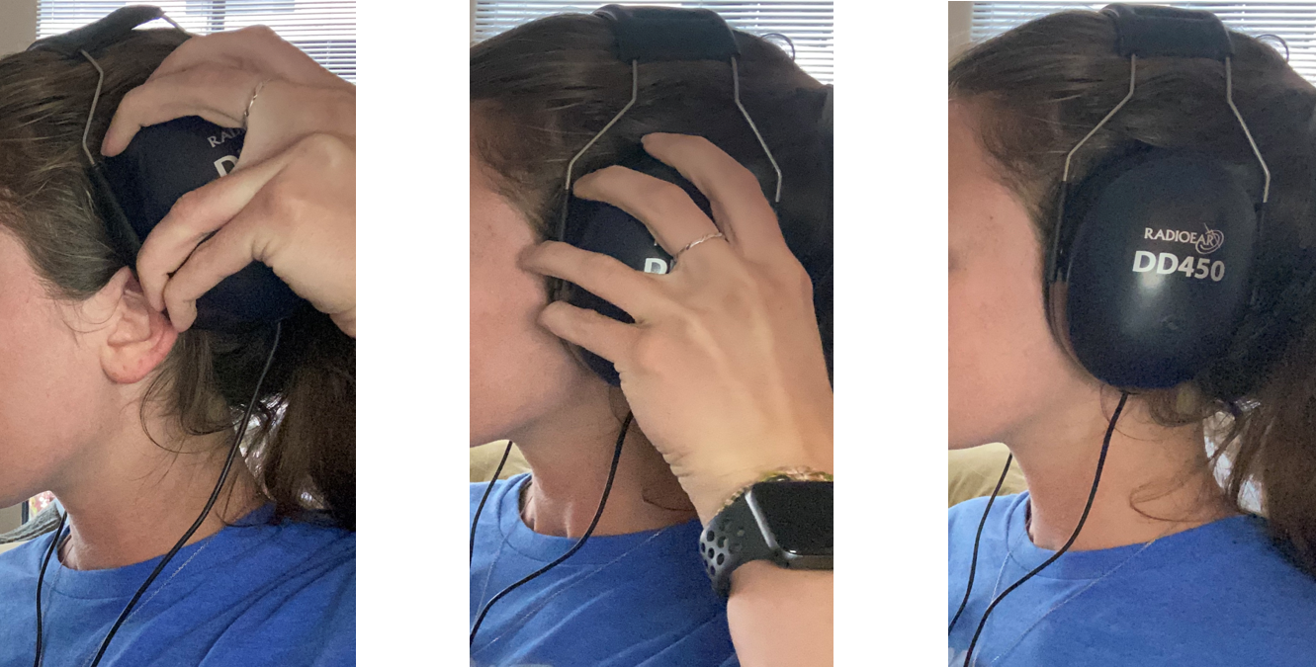
Figure 13. Please note that the ear is pulled back slightly. ALSO NOTE THAT GLASSES SHOULD BE REMOVED PRIOR TO HEADPHONE PLACEMENT

Opening Software
To open the software:
- Select the OtoAccess Suite on the desktop or from start-up menu
- Enter participant first name, last name, ID, and birthdate and save
  - Note: this computer must be password protected as it will have participant identifier information saved
- Double click Affinity Suite under “Select Instrument” to open the software

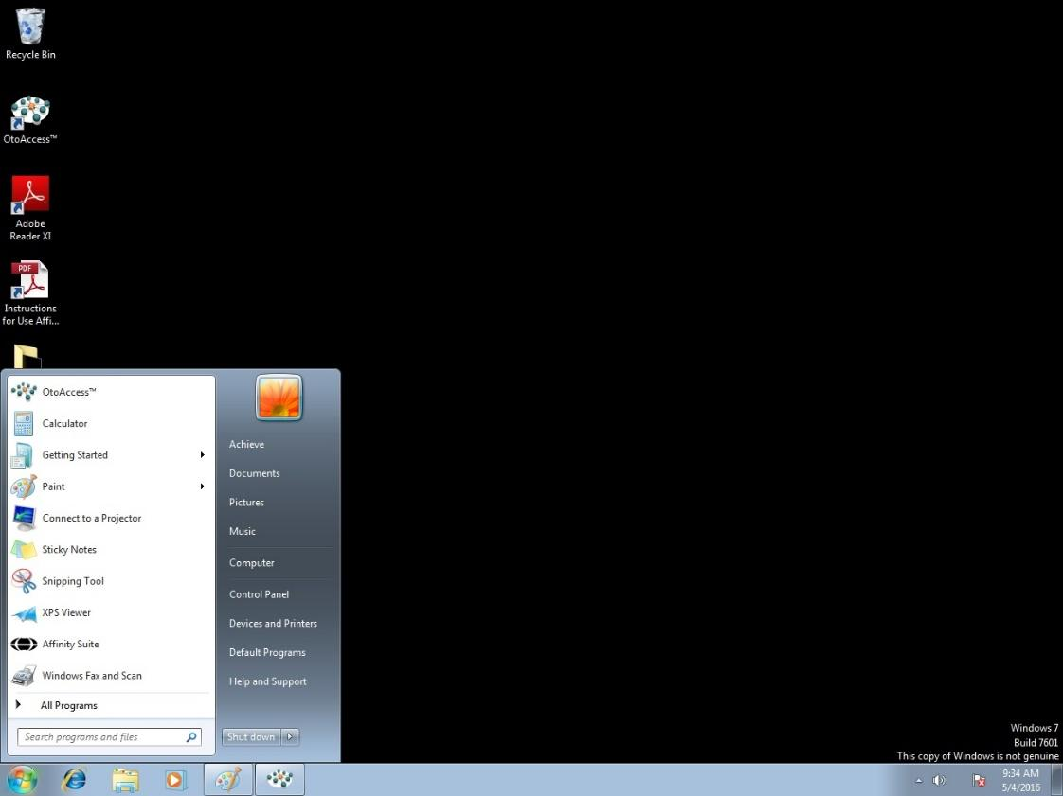

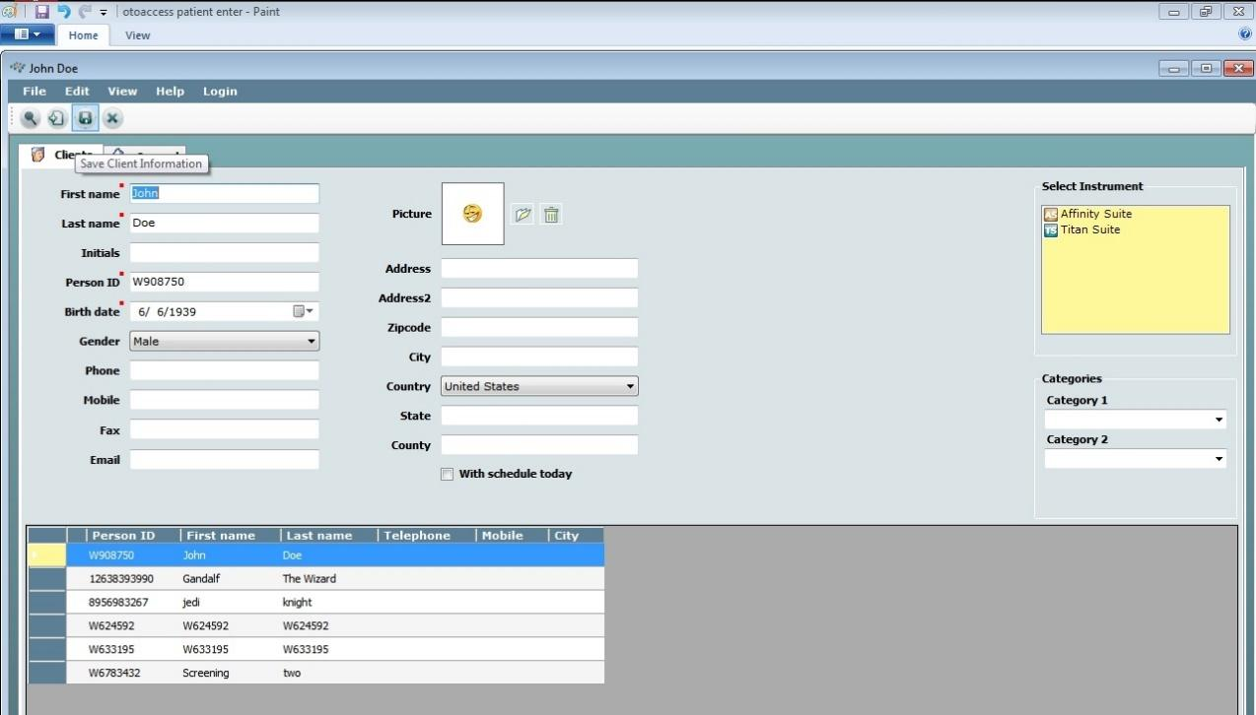

Manual Hughson Westlake Testing
Threshold will be defined as the lowest intensity or volume (dB HL) at which a tone has been heard by the participant at least 50 percent of the time following a minimum of three ascending (i.e., increasing) presentations at a level (i.e., 2 out of 3, 2 out of 4, 3 out of 5, etc). To simplify, tones will be presented in an up 5 and down 10 pattern; when participants respond at least 2 out of 3 times at one level during the up 5 portion, that will be the threshold.
- Select the ‘musical note’ icon to activate the pure tone screen.

- Overview of Controls
  - Click on arrows next to “stimuli” [1] or use ↑↓arrow keys on keyboard to change intensity (dB) or volume
  - Use the central arrows [2] or ←→ arrow keys on keyboard to change the frequency (Hz)
  - Press _∏_ and _∏_ _∏_ [3] to activate one pulsed or continuous pulsed tones. (Set to continuous pulsed tone _∏_ _∏_)
  - Press spacebar key to present tone
  - Press enter key to save threshold to screen
  - Press TALK FORWARD [4] to talk to subject (Note: when using talk forward, please make sure the sound is not above 70 dB HL unless participant has extreme hearing loss and cannot hear at that level)
  - Other set-up:
    - Make sure ch1 and Talk Back are checked. Ch 1 is the channel you are manipulating. Talk Back is your ability to hear the participant in the booth – set the number next to talk back to adjust the volume.
    - Man. should be selected so that a tone presents when you present the tone with the space bar on the keyboard
    - Note that masking should not be selected



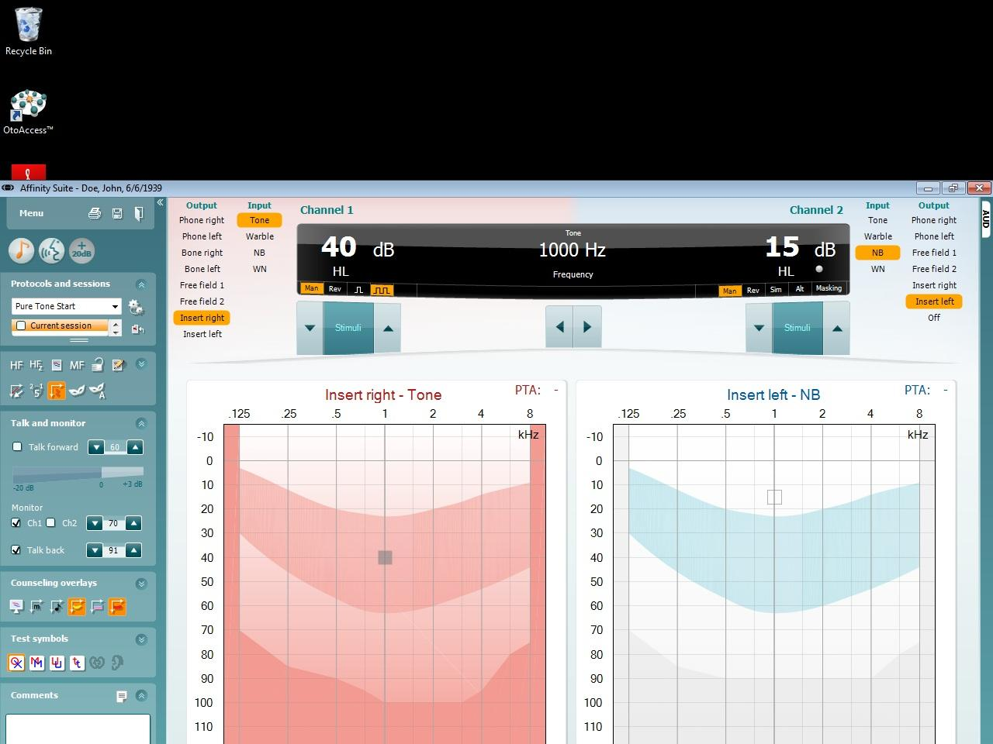


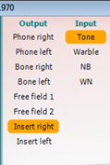
- If a technician feels an extra set of instructions is needed, now is a good moment to re-instruct the participant (through the headset microphone) by pressing down on the TALK FORWARD button: “You will hear a beep sound. When you hear a beep sound, press the button in your hand for about 1 second and let go. Do not press the button if you do not hear a beep.”

- Select the test ear (based on last digit of ID number) and appropriate transducer (Phone). In the channel 1 box, select the phone since headphones are being used in testing and make sure the appropriate ear (right or left) is selected based on participant ID number.

- Begin by presenting a tone (pressing spacebar) at 1000 Hz (x-axis) at a hearing level of 40 dB HL (y-axis) to the appropriate start ear based on subject ID number by holding the spacebar for approx. 3 pulses (i.e., 3 beeps)

- If the participant does not respond at 40 dB HL, increase the tone presentation level by 20 dB steps until the participant responds (note: a participant that converses with relative ease (i.e., not asking you to speak up or shouting should be able to hear beeping at 40 dB HL)
  - If the participant does not respond at 80 dB HL, check the equipment to ensure it is functioning properly, and repeat the instructions and retest
  - If the participant does not respond at the maximum limits of the audiometer, record this as NR or no response in the CRF at 1000 Hz

- After a response occurs, decrease the tone by 10 dB HL (y-axis) and present the signal again. Repeat this descending pattern until there is no response.

- When there is no response, increase tone in 5 dB HL (y-axis) steps until participant responds.

- Continue this pattern – decrease tones in 10 dB steps until no response and increase in 5 dB steps until the participant responds.
  - Count this response toward the threshold
  - Example sequence of threshold determination:
    - Present 1000 Hz at 50 dB – Participant responds
    - Present 1000 Hz at 40 dB – Participant responds
    - Present 1000 Hz at 30 dB – Participant responds
    - Present 1000 Hz at 20 dB – Participant does not respond
    - Present 1000 Hz at 25 dB – Participant responds
    - Present 1000 Hz at 15 dB – Participant does not respond
    - Present 1000 Hz at 20 dB – Participant does not respond
    - Present 1000 Hz at 25 dB – Participant responds
    - THRESHOLD IS RECORDED AS 25 dB in this example
- Threshold is measured when there are 2 responses at the same level in response to ascending presentations [Note: threshold is defined as 2 responses out of no more than 4 presentations at that level].
  - In the case that a participant is inconsistent in their responses, re-instruct the participant and encourage them to only respond when they are sure they heard the tone
  - It is acceptable to skip a frequency and return to it later if the participant is inconsistent at one frequency – sometimes participants need a break from that frequency

- Record the threshold on screen by pressing enter and record the threshold on the CRF (it is critical to continuously record the thresholds in the case that the computer shuts down or data is lost due to software error).

- Proceed to the next frequency (500 Hz, 250 Hz, Repeat 1000 Hz, 2000 Hz, 3000 Hz, 4000 Hz, 6000 Hz, 8000 Hz) using the arrow keys or central arrows on the screen and continue testing using the same pattern (steps 8-15).
  - Note: rather than starting at 40 dB HL at each frequency, it is faster to simply start ~10 dB HL above the previous threshold.
    - For example, if the participant has a threshold of 15 dB HL at 250 Hz, it is faster to start threshold searching at 25 dB HL at 500 Hz.
  - When repeating the test procedure at 1000 Hz to confirm threshold: If the difference is 5 dB or less, move on to the other ear. If the difference is ≥ 10 dB, re-instruct and repeat the test before moving on.
  - The second 1000 Hz will overwrite the first one in the software, so the first must be recorded in the CRF.

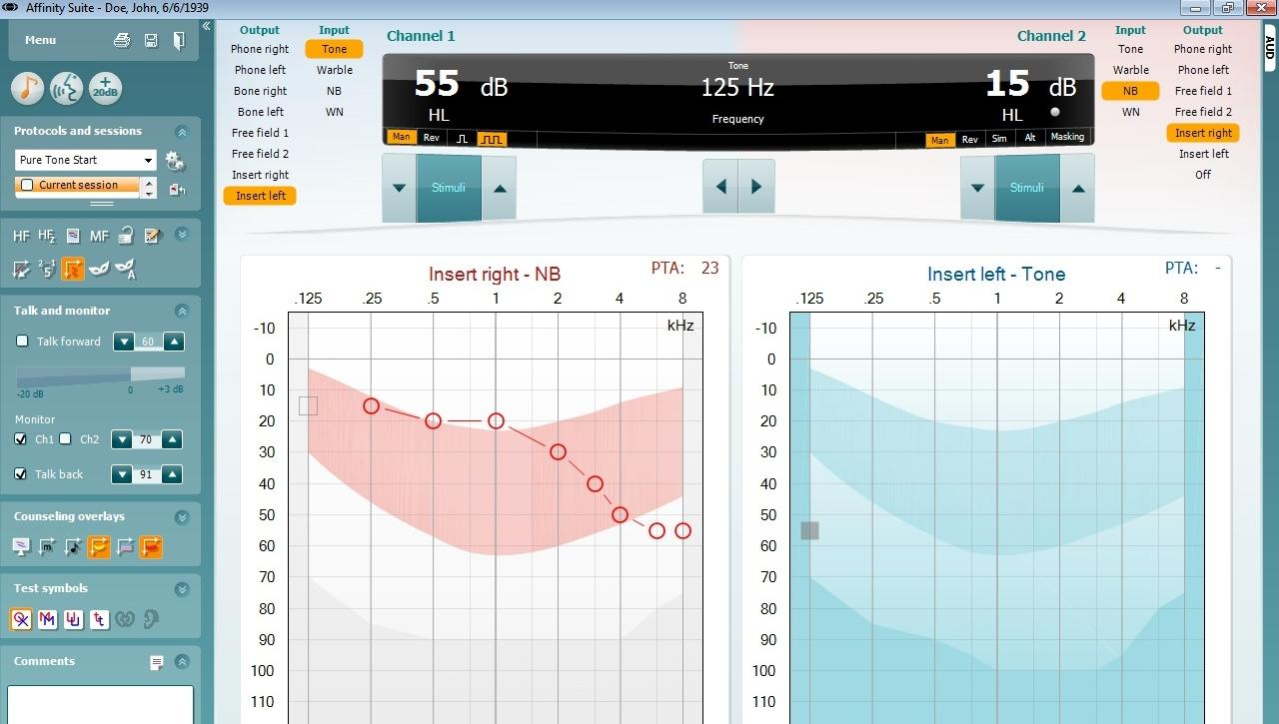
FIGURE: note that other ear is now highlighted (in this case, the left)

- When thresholds have been obtained at all frequencies in the first ear, press anywhere in the other ear section of the screen or select by clicking on the different transducer (e.g,. Phone Left or Phone Right). Set volume to 40 dB and frequency to 1000 Hz. Conduct the test in the second ear in the same way as the first ear.
- After pure tone thresholds are obtained, use ‘TALK FORWARD’ to let the participant know this portion of the testing is complete and you will now set up for a different task and they can relax for a minute.
  - At this point, please make sure the CRF is updated before moving on in case there is an issue saving data.
  - Record any instances where the maximum limits of the audiometer were reached as NR or no response on the CRF and any instance where thresholds could not be obtained (for whatever reason) as CNO.

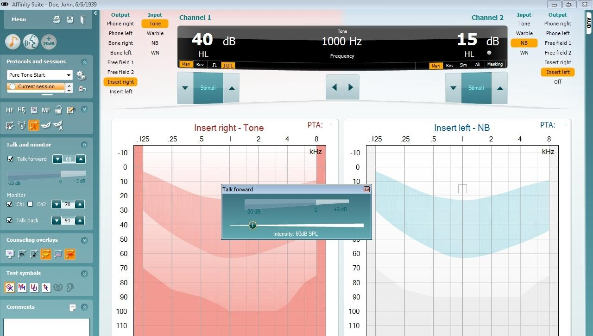

Considerations
Vary the interval between the stimulus presentations (i.e., wait longer between presentations intermittently) to prevent the participant from falling into a pattern of responses
Do not present the stimulus longer than approximately 1 second (~3 pulses)
Avoid giving visual cues that may influence the participant by indicating the technician is presenting the signal
Try not to distract the participant during testing
Feel free to skip a particularly difficult frequency (i.e., too much inconsistency in responses) and return to it later
Periodically wait 8-10 seconds between presentations to avoid false positive responses
Remember that only ascending (up 5) presentations count towards threshold
Avoid being influenced by the initial threshold at 1000 Hz when performing the re-check
If the threshold is beyond the limits of the equipment, do not hit enter on the screen as there is no threshold to record

Reinstruction
Reinstructing the participant can sometimes help to alleviate a difficult test situation or improve the accuracy and efficiency of the threshold test. Reinstruction is helpful in situations that involve a misunderstanding of test instructions. When reinstructing the participant, tailor the reinstruction to the specific circumstance. For example:
- Participant pushes the button for each beep in the series
  - Reinstruction “You will hear three beeps in a row, please press the button only once.”
- Participant waits for all beeps to play before responding
  - Reinstruction “Please press the button as soon as you hear the three beeps.”
- Participant fails test/retest at 1000 Hz
  - Reinstruction “Please be sure that you hear the tone before you press the button” OR “Please press the button even if the tone sounds very soft”.
Some situations may require test accommodations such as those outlined in the Difficult Situations section below.

Difficult Situations

Significant pre-existing hearing loss
Some participants with significant hearing loss will be quite experienced with audiometric testing procedures and may not present much of a challenge at all. But others will not be familiar with the threshold testing procedure and may have difficulty hearing the test instructions. Face the person when you speak and talk a little more slowly than usual (but don’t exaggerate your facial expressions). Use motions to help augment your message. You may rely on the ‘TALK FORWARD’ feature to explain instructions as you can increase the level of your voice.

False Positives/Inconsistent Responses
Responses, which continuously vary over a range of more than 10 dB, are too inconsistent to accurately determine threshold. In such cases, the best course of action is to reinstruct the participant, indicating that he or she should only respond when certain that a tone is heard. Remind the participant that the signals will be a series of three pulses; instructing the participant to wait until he or she has heard at least two of the pulses may also help resolve the problem.
If the false positives/inconsistent responses are only at one frequency, try skipping that frequency and coming back to it later. Sometimes the participant just needs a break from listening to the same signal.

Tinnitus
Tinnitus (the presence of ringing or other sounds in the ear) can make it difficult for the participant to distinguish the test tones from the other noises he or she hears. The pulsed tone specified by the protocol should alleviate this problem. It may be necessary to skip the frequency corresponding to the participant’s tinnitus.

Fatigue
Listening for signals near threshold level is a difficult and demanding task. A participant may weary of it quickly; if the participant arrives fatigued, he or she may have difficulty staying on task. Verbal reinforcement may help keep the participant alert; you can speak to the participant through the headphones by using ‘TALK FORWARD’.

Poor coordination/long tone-response latency
Some participants may be slow to respond when they hear the test tones, due to poor dexterity or other reasons. Reinstructing the participant to respond as soon as he or she hears the signal may help the situation. Otherwise, try to get a feel for the “rhythm” of the participant’s response pattern so that you will better know when a response is valid and when it is random. You may practice by presenting a tone above their threshold* several times and give positive feedback when the participant correctly responds each time. This should not be counted towards threshold responses.
*70dB at 500 Hz is appropriate for most participants.

Dexterity
Some participants cannot press the response button and will need to raise their hand or simply say ‘yes’ whenever they hear the tone. If another method of responding is more workable (e.g., raising a finger, nodding the head, etc.), use it.

Comprehension or language difficulties
If a participant has difficulty understanding the test instructions, try another mode of communication. Use motions to demonstrate the test directions while you explain them. If a family member or friend accompanied the participant to the visit and is available, ask him or her to help you explain the procedures to the participant.

Anxiety
Some participants may be anxious about the test, for various reasons. Perhaps the most common is claustrophobia. Try to put the participant at ease as much as possible by ensuring them we are able to hear them, and they are able to exit the booth at any time. In some cases, it may be possible to conduct the test with the door to the sound room partly or completely open.

QuickSIN- Speech-In-Noise-Test
NOTE: supra-aural headphone will remain on for the duration of this task
QuickSIN, a test comprised of sentences recorded in four-talker babble, is used to quantify the participant’s ability to hear in noise and to provide a quick estimate of signal-to-noise ratio (SNR) loss. SNR loss is defined as the dB increase in signal-to-noise ratio required by a hearing-impaired person to understand speech in noise, compared to someone with normal hearing. To clarify, this is a test where sentences are presented in different levels of background noise to find the level at which the participant can understand speech in background noise.
The subject will be asked to repeat lists of sentences presented in four-talker babble noise. Each sentence contains five key words. Each list takes approximately 1 minute to administer.
Technicians will record the number of the 5 key words repeated correctly for each sentence.
To select the QuickSIN test from the pure-tone screen, use the drop down menu and select Tests and then QuickSIN
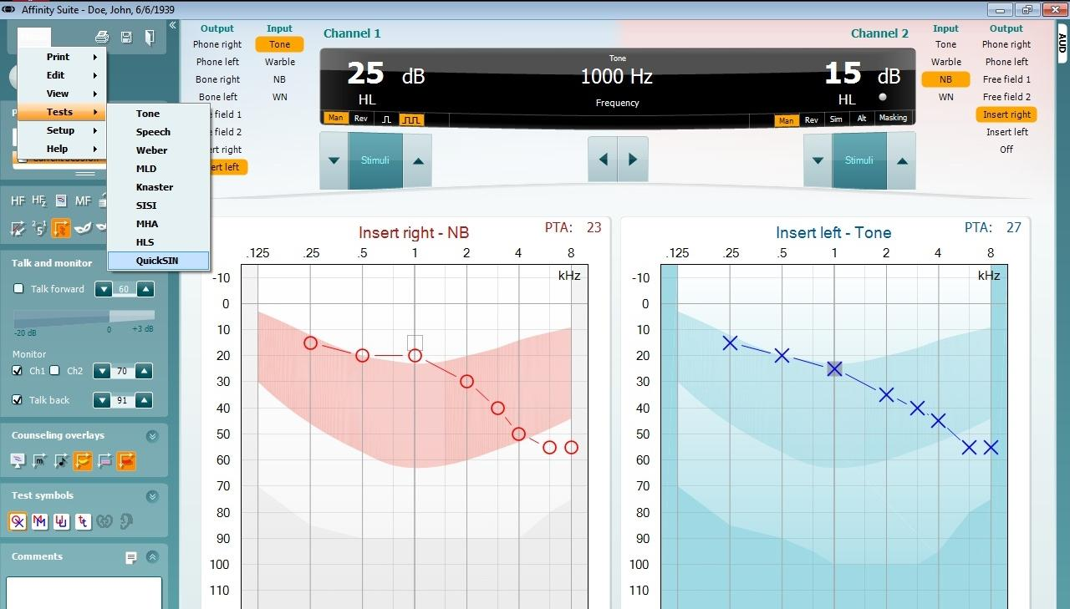

Administer the QuickSIN following the appropriate steps and conditions shown below:

Controls for QuickSIN screen
- The arrows surrounding ‘Stimuli’ [1] control the level of the signal
- The drop down menu [2] allows the technician to select the appropriate list
- The Start [3] button allows for presentation of sentences
- The numbers in the center of the screen [4] allow for scoring of sentences (e.g. 5 = all 5 bold words are correct while 1 = only 1 out of 5 bold words were correct)

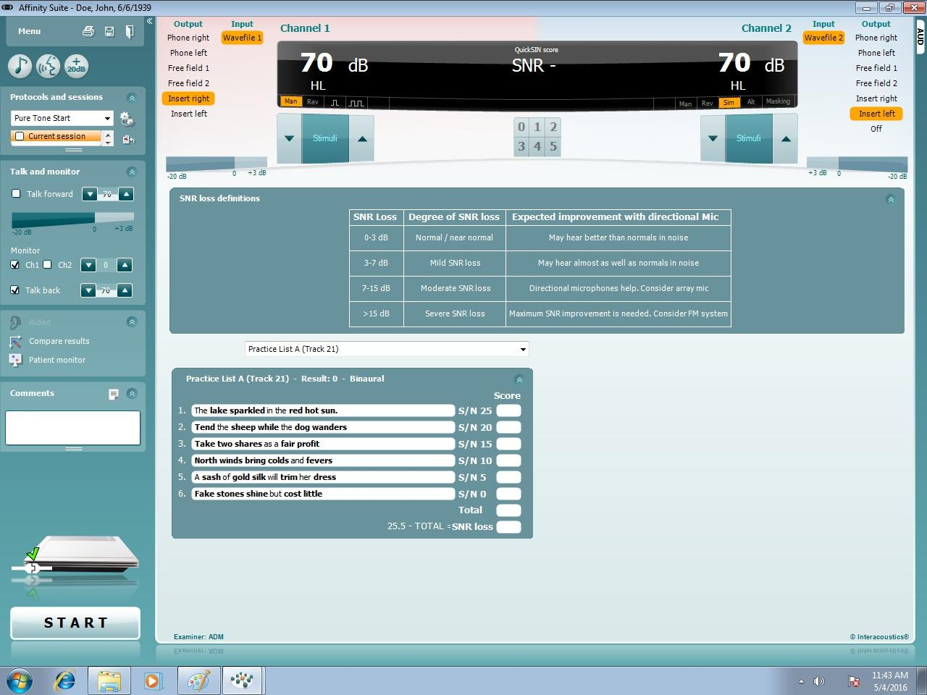

Initial Set-up for QuickSIN administration
- Make sure ch1 and ‘Talk Back’ are selected (Allows technician to hear the participant)
- Set Channel 1 and Channel 2 to 70 dB
- Channel 1 should have Phone Right while Channel 2 should have Phone Left selected
- Practice List A should be selected from the drop down menu
- Channel 1 will have Man. highlighted while Channel 2 will have Stim. highlighted

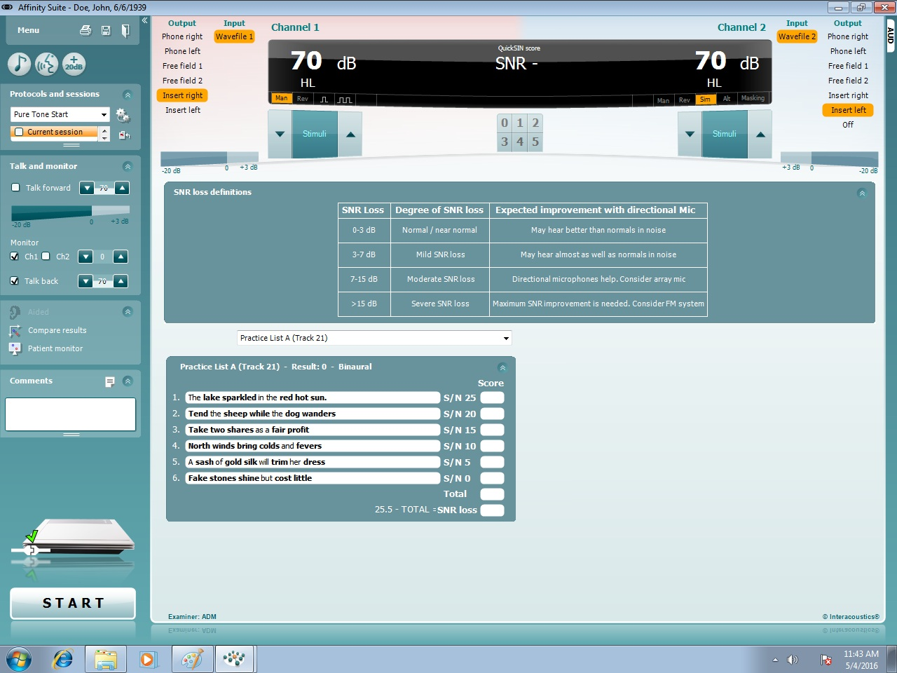

Procedure

- Explain to the participant: “This next task will involve repeating sentences that you will hear with varying levels of background noise. Imagine that you are at a party. There will be a woman talking and several other talkers in the background. The woman’s voice is easy to hear at first, because her voice is louder than the others. Repeat each sentence the woman says. The background talkers will gradually become louder, making it difficult to understand the woman’s voice, make sure to please repeat as much of each sentence as possible and guess if you aren’t sure. We’re going to do several sets of sentences, just keep doing your best throughout the task. Do you have any questions?”
- First administer Practice List A to familiarize the participant with the task.
  - Press Start to begin the test
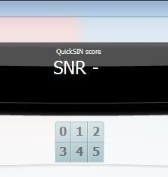
  - The software will automatically adjust the background noise level
  - After the sentence is presented, wait for the participant to repeat it
    - If the participant does not repeat it automatically, please prompt them to by asking them to repeat what they heard the woman say
    - NOTE: Use the ‘TALK FORWARD’ button to communicate with the participant
  - Score as appropriate based off the number of correct words in bold repeated
    - NOTE: it is ok if the participant doesn’t get the words not in bold, only the 5 bold words matter, and order is not important
  - To present the next sentence in the list, the previous one must be scored by pressing the appropriate number in the center of the screen
  - Note: the scoring for the practice list is not recorded on the CRF
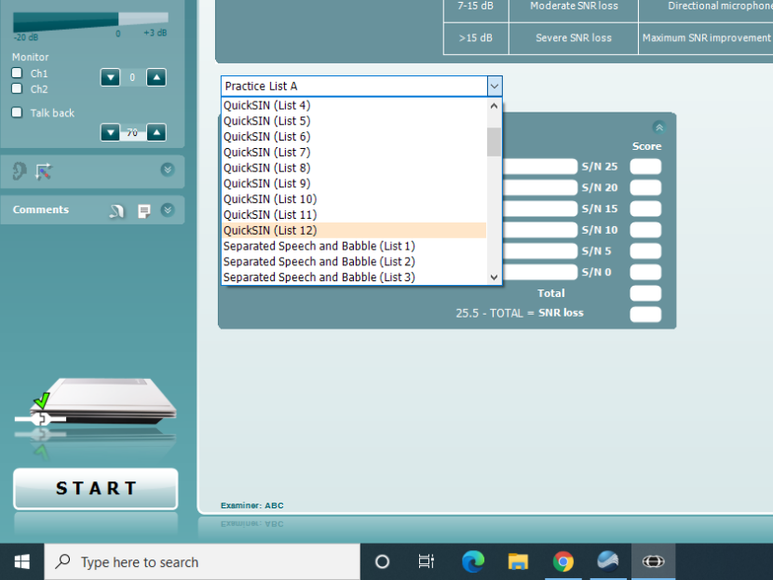
- After completing the practice list, use the drop down menu to select QuickSIN (List 12).

- Administer the QuickSIN (List 12) just as the practice list.
  - Wait for the participant to repeat the sentence (prompt if necessary)
  - Score using the numbers in the center of the screen
  - The background noise will automatically increase
- Record QuickSIN (List 12) results on the CRF.
- Use drop down to select QuickSIN List pairs (List 15) and repeat steps to present and score the list.
- Record QuickSIN List pairs (List 15) results on CRF.
- At this point, all audiometer-based testing is complete. Let the participant know you will be over in a moment to remove headphones.
- Please ensure everything has been recorded on the CRF. Click the save icon on the screen and it is safe to close the Affinity Suite Software (Note: OtoAccess will remain open).
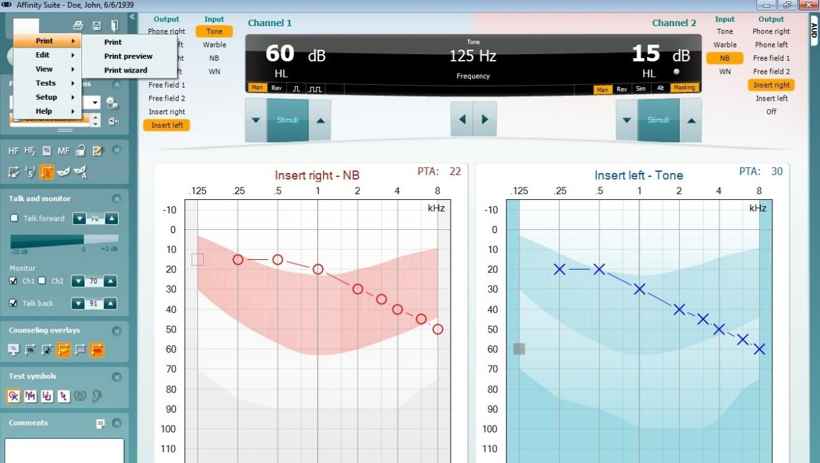

- Enter the booth and remove headphones.
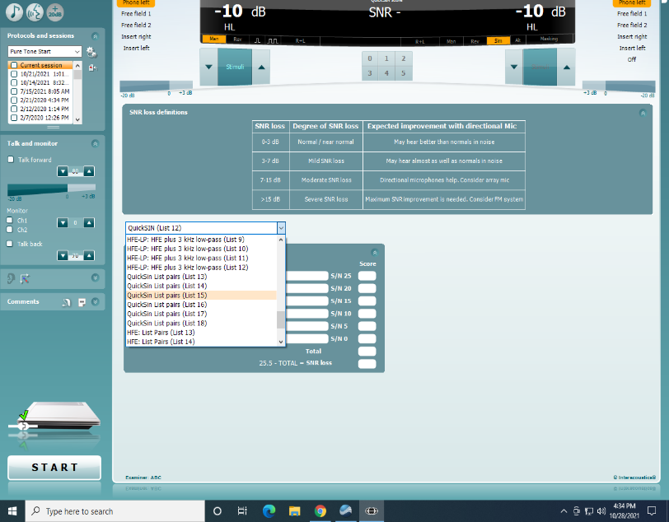

Considerations

Participants may display great difficulty with this task, as it requires normal hearing and normal cognition and places a great deal of load on the auditory system. Please encourage them throughout the task so they do their best. For example:
- Please try to guess, but it’s OK to say, “I don’t know,” if you cannot understand any of the words.
- You’re doing fine, only a few more sentences to go.
Participants may miss the last two sentences completely, even those with normal hearing.
Many will want to know how they did after the test; it is acceptable to let them know if they have a specific question about what the sentences were.

Results Reporting

Results will be provided to participants as a part of the Visit 12 Summary of Results. Audiometry results for Visit 12 include a hearing loss evaluation, which is based on the pure-tone average of the better ear. Normal hearing is defined as a PTA of ≤ 25 dB HL. Mild hearing loss is defined as a PTA between 26-40 dB HL. Moderate hearing loss is defined as a PTA between 41-70 dB HL. Severe hearing loss is defined as a PTA ≥ 71 dB HL. See MOP 2 Results Letter Templates (provided on the ARIC website) for the results reporting template.

CHAPTER 5: HOME VISIT AUDIOMETRY PROTOCOL (hearX)
For the home visit, technicians will conduct pure tone audiometric screening following the questionnaire; the QuickSIN test will not be collected. Audiometric testing will be completed using the hearX system. Moreover, unlike the clinic-based visit, only supra-aural headphones will be used during home visits.

Prior to Testing
Eligibility and Contraindications for Hearing Testing
The following are reasons why the participant would be excluded from assessment:
- Active infection or drainage from the ear
- Acute dizziness or vertigo
- Reported pain or discomfort
- User of a surgically implanted cochlear device (e.g., Cochlear Implant, Bone Anchored Hearing Aid or BAHA)

Room and Participant Preparation
All screenings should be conducted in a quiet room. This should be assessed prior to any testing of the participants for running the ambient noise analyzer in the hearX application). Ensure that extraneous noise such as ventilation systems, conversations, and electronic equipment is limited as much as possible near the audiometric room.
Testing should take place with the participant in a comfortable position, ideally sitting a chair with the technician standing behind or to the side of the participant as the participant should not be able to see the technician pressing buttons during testing (it may prompt the participant to provide false positives).
Device Preparation

- Open Samsung device and enter the passcode (if applicable/prompted).
  - Screen will open to hearX Application (Figure 1)
  - Select “mHealthStudio” to access hearTest (Figure 1)
  - If account setup was successful, device will be ready for testing (if not, rerun the startup wizard)

- Tap ‘START’ (Figure 2)
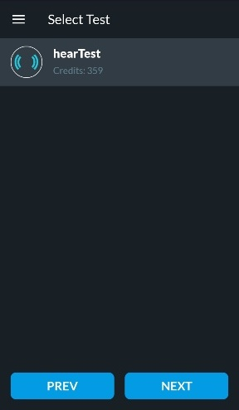

- Select ‘hearTest’ (Figure 3) and press click ‘NEXT’
Figure 3

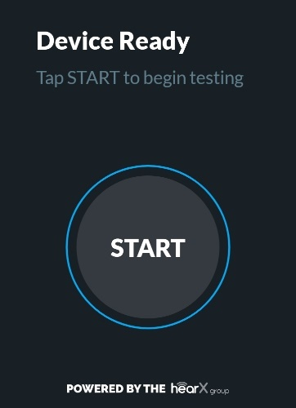
Figure 2
Figure 1

4. ”Default Facility” (Figure 4) is auto-selected. No need to edit.
5. To add a participant, click the circled + at the top of the page to ‘Add new’ (Figure 5).
  - Under ‘General,’ add “ARIC” for First Name, “V12” for Last Name according to protocol. Keep the date auto-selected on 2005-01-01. Keep the gender auto-selected on “Male.”

  - Click on the tab ‘Additional’ and select the camera associated with the Medical Record Number (Figure 7).
    - Hold the camera over the barcode specific to your participant (Figure 6), and the barcode will auto populate (Figure 7). Then, click ‘SAVE’ and ensure the appropriate participant is selected before moving on.
  - Disregard the Job tab.

6. Click the ‘checkmark’ box to confirm participant consent was provided and click ‘Next’ to continue (Figure 8).

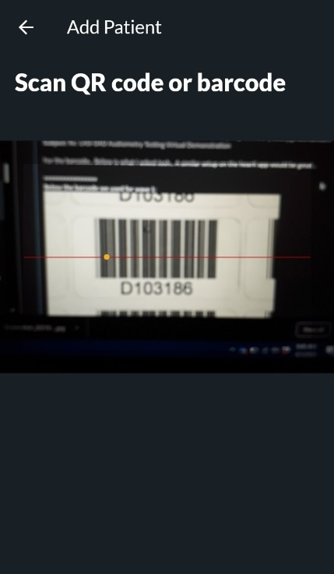
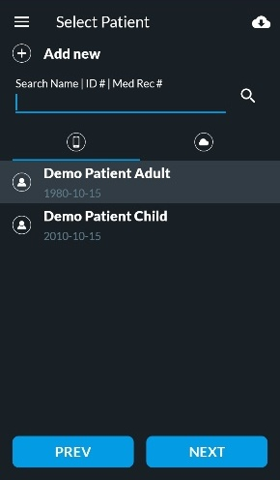
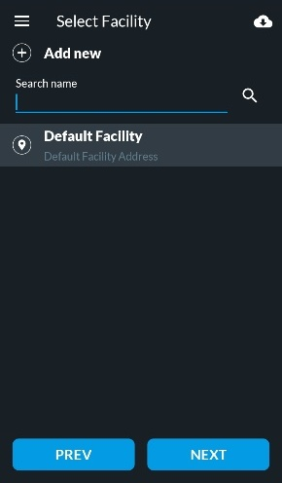

Figure 4
Figure 6
Figure 5
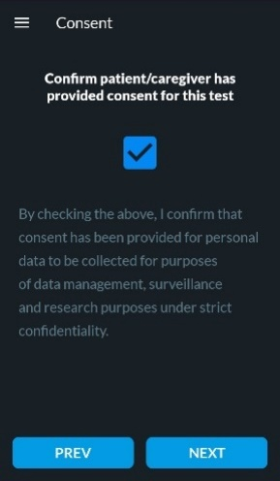
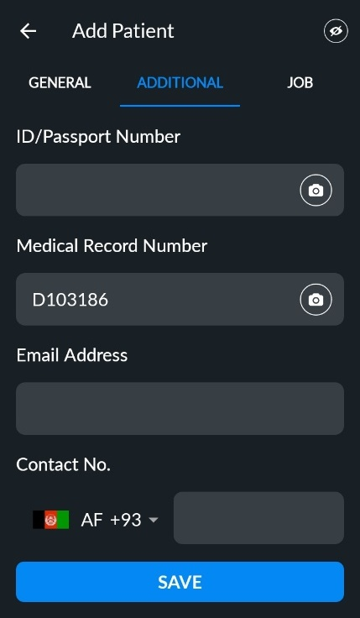

Figure 8
Figure 7

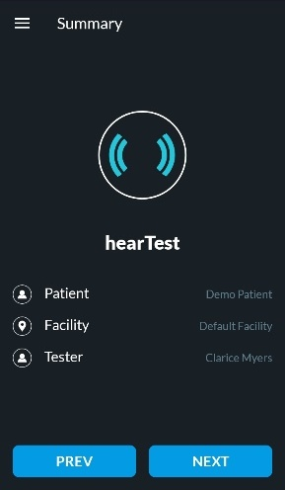
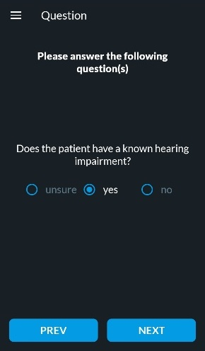
7.Ask participant if they have a known hearing impairment. Select the appropriate answer here (Figure 9). Note: the equipment asks this question to calibrate how loud it will begin the test procedures.

- Once the above steps are completed, a summary page will appear. Ensure all information is correct before proceeding (Figure 10). Touch the ‘Next’ button.
Figure 10
Figure 9

- At this point the system will return to a home screen (Figure 11).
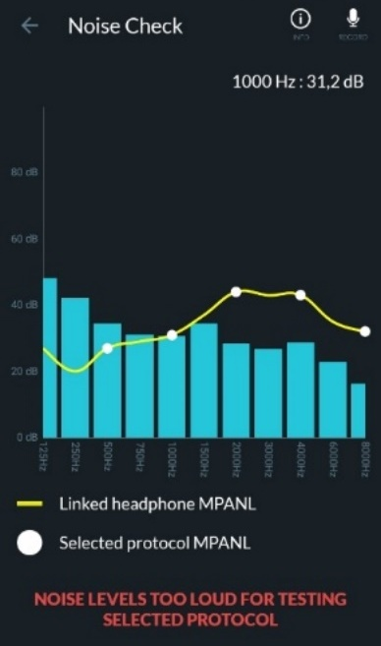
10. Click the ‘Noise Check’ button and proceed with the noise check in the location selected for testing (as quiet an area as possible). Prior to the noise check, ask the participant to remain quiet (any talking will interfere with the noise check). During the noise check, all blue bars should fall under the yellow line (Figure 12). If the noise levels are too loud in the area you are performing the hearing screening, the results may be inaccurate, and a warning will present (Figure 13). Record the results of the noise check on the AUD Form (this information will inform quality assurance of data at later stages) and proceed regardless of noise levels.
Figure 13
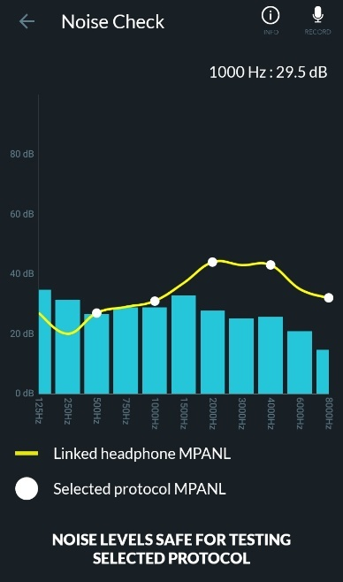
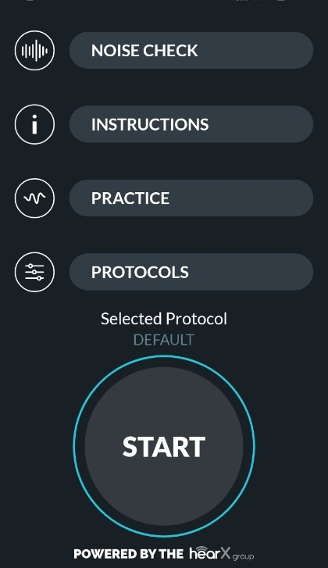
Figure 12
Figure 11

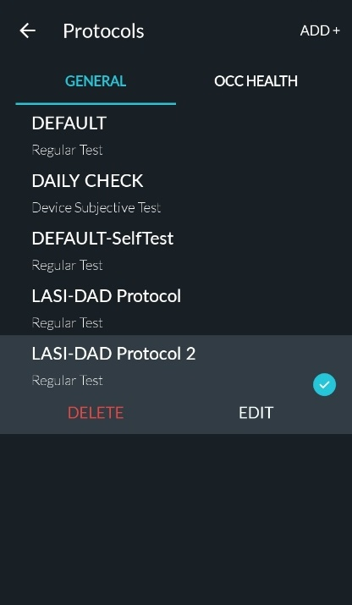
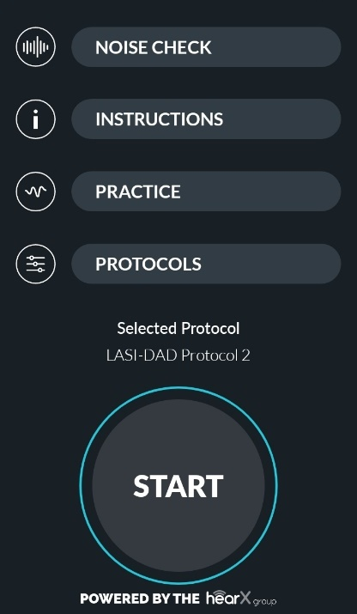

11. Click ‘PROTOCOLS’ on the
home screen to ensure the correct
testing protocol is selected
(Figure 14)

- Select ‘YOUR STUDY
PROTOCOL’ (Figure 15).
Click the back arrow in the top
left-hand corner of the screen.

13. The appropriate protocol will
be revealed above the START
button (Figure 14).

Figure 15
Figure 14

Participant Preparation
Now that the device is set up, we are ready to begin testing. Prior to headphone placement, please give the participant instructions on what to expect during testing. Best practice is to face individuals while giving them instructions as visualization of the mouth will improve communication. If the participant wears hearing aids, please give them instructions while they are wearing their hearing aids.
Instruct participants with the following:
“Today we will complete a hearing test. In a moment, I will ask you to remove any items on or around your ears, such as glasses, jewelry, or hearing aids, and I will place these headphones over your ears and stand behind you during testing. You will hear tones and beeps that will vary in pitch, getting softer and louder over time. Whenever you hear the tone, please raise your hand, and then lower your hand to wait for the next tone. If you cannot raise your hand, please say ‘yes’ when you hear the tone. Please raise your hand even if you think you hear the tone as we are looking for the softest level at which you can hear sounds.”
Always verify that the participant understands the instructions prior to proceeding with testing.
At this time, please have the participant remove hearing aids of any type and any other items on their ears, such as glasses and/or jewelry prior to testing as headphone placement may be affected. Note: per contraindications above, testing cannot be completed if participant has cochlear implants.

Headphone Placement
NOTE: The participant’s Right Ear is indicated by a Red Square and the letter ‘R’ and the participant’s Left Ear is indicated by a Blue Square and the letter ‘L’.
1. To place headphones:
- Stand behind participant.
- Ensure the headphones are aligned properly with the red square over the participant’s right ear and the headphone with the blue square over the participant’s left ear.
- Bring the headphones over the participants ears and place the headphones by using an upward motion so that the ear canal remains open (see Figure 16 and accompanying video). This will prevent the canal from being smushed and occluded by the headphone.
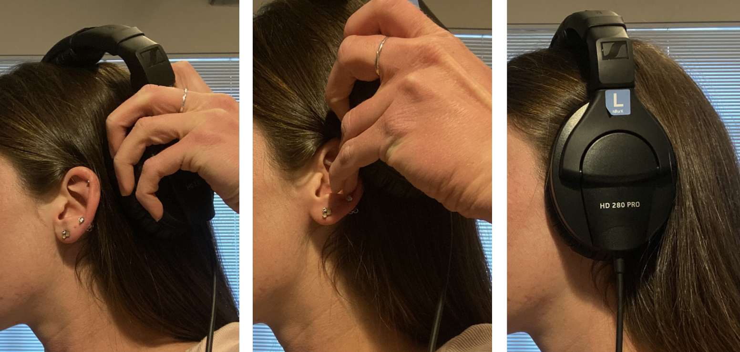
- Ensure the headband are properly adjusted; the fit on participant’s head should be tight and participant should be comfortable.
Figure 16

Pure Tone Testing
- Pure Tone Testing Practice Test (OPTIONAL)
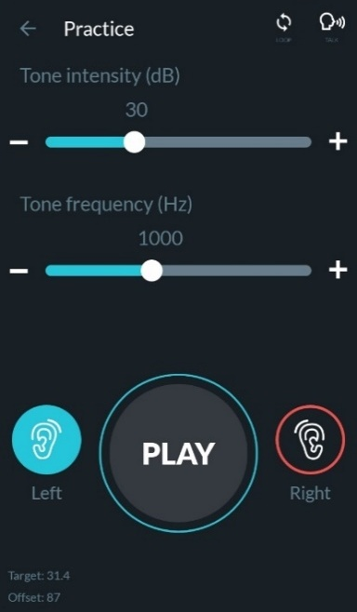
  - To familiarize the participant with the procedures, run a quick practice test by pressing the ‘PRACTICE’ button on the home screen (Figure 11).
  - Use the ‘-‘ and ‘+’ symbols on the slider bars to adjust the configuration to play a 50 dB signal (tone intensity) at 1000 Hz (tone frequency). Set the ear to either ‘Left.’ Press ‘Play’ to produce a signal. Now set the ear to ‘Right’ and complete the same procedure.
    - The participant should respond by raising their hand.
    - If the participant does not respond, increase the tone intensity to 70 dB and repeat.
    - If the participant does not respond at 70 dB, please ask them if they heard it and reinstruct as appropriate.
      - If the participant says they did not hear the tone, proceed to the maximum allowable intensity for testing. Note: this is an indication the participant has ‘profound’ hearing loss.

Figure 17
- Hearing Test
  - Return to the home screen and press ‘START’ (Figure 11). The device will prompt the tester to press the play button which presents the tone and starts the test (Figure 18).
    - Figure 19 shows the tester which ear the tone is playing in, which frequency is playing (in Hertz or Hz), and which intensity is playing (in decibels or dB).
  - If the participant raises their hand indicating they heard the tone, the tester will press the green check mark button (Figure 20).
  - If the participant does not respond to the tone indicating they did not hear it, the tester will press the red X button (Figure 20).
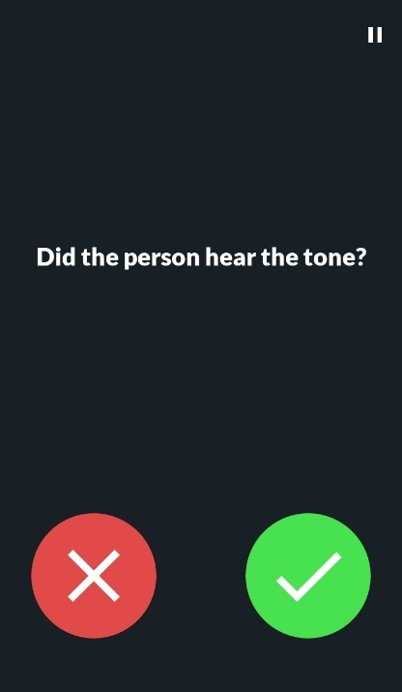

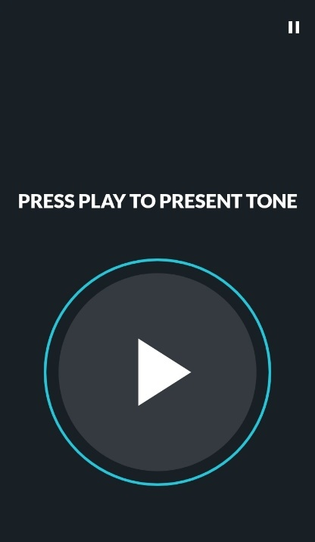
Figure 18
Figure 19
Figure 20

Troubleshooting
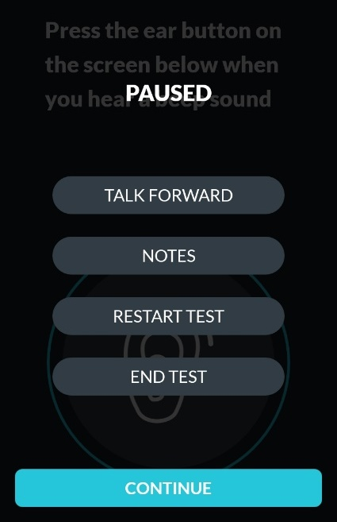
At any time, testing can be paused by selecting the pause button () in the top right-hand corner. From here, “Talk Forward” can be used in the case instructions need to be repeated, “Notes” can be accessed if needed, and the test can be restarted or ended (Figure 21).
Some common needs to reinstruction:
- Participant is unresponsive → clarify that the participant understands the task of raising their hand when they hear a tone. Note: unresponsiveness may indicate profound hearing loss, but it is rare (especially if the participant was able to hold a conversation prior to testing without the use of hearing aids)
- Participant is overly responsive (i.e., keeps hand raised without putting it down) → simply reinstruct to lower hand between beeps/tones
Figure 21
- Since testing is only a screening, it will last about 6 minutes. However, there is possibility of participant fatigue, meaning participant no longer raises hand when they hear the tones. If this happens, please pause testing, and offer reinstruction.
  - If participant continues to give inconsistent responses or gets frustrated with testing and testing is ceased, data will be saved as incomplete. For results to show, please do not cease testing until it is complete. If a participant is not cooperative, end testing and make appropriate notations according to the protocol. The chosen protocol on the device (see 4.3.12.) is the fastest version of testing to aid in participant fatigue.
Hearing Screening Summary
- Upon completion of hearing screening:
  - A summary page will appear showing hearing ability. It will show degree of loss, if applicable, for each ear (Figure 22).
  - The ‘Audiogram’ option will display the graphical representation of the users’ hearing levels. The X-axis will display the specific frequencies (Hz) while the Y-axis displays the hearing threshold in decibels (dB) of hearing. The blue X represents the left ear, and the red O represents the right ear. (Figure 23).
  - Reliability: This page will show whether test results were reliable and which factors played into that decision. In the example in Figure 24, the noise bars for low frequency sounds are above the dotted line which is an example of a room with inappropriate noise levels and the device indicated that retest reliability (built into the algorithm) differ by wide margins.
- After reading results, click SAVE in the top right-hand corner.
- At this time, testing is complete, and headphones can be removed from participant; you may warn them that you will remove them.
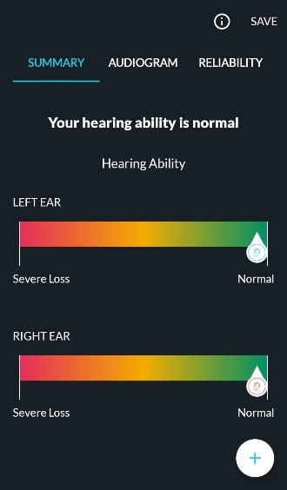
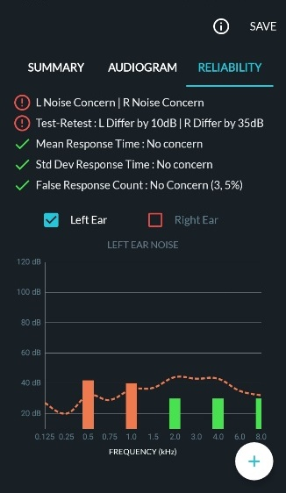
Figure 22
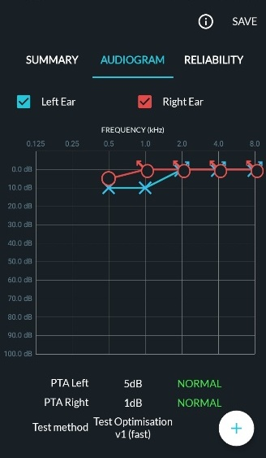
Figure 24
Figure 23

Visit Completion
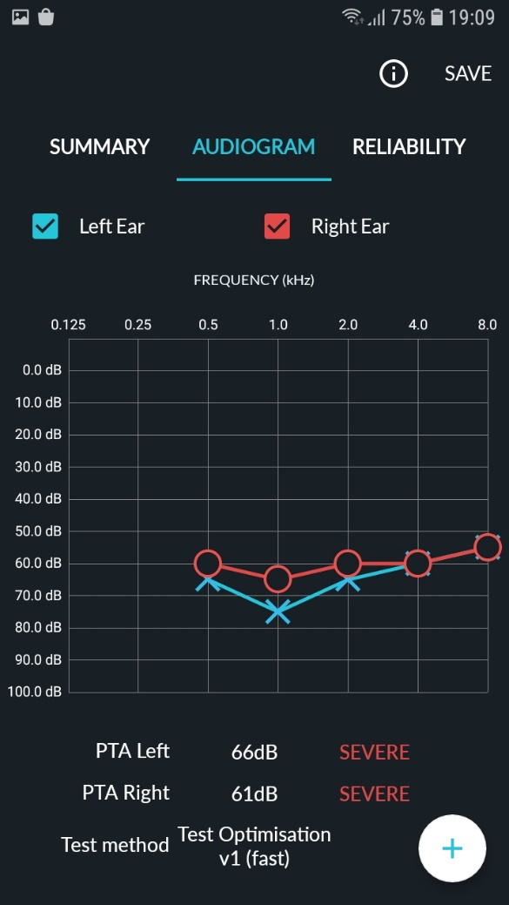
Thank the participant
Acknowledge gratitude to participant for their time and contribution to science.

Documentation of Results
Results will be saved via audiogram in the hearX application.
To document thresholds on the AUD Form, bring up the ‘Audiogram’ page. On this page, use the graphical information to document the thresholds. The frequency is on the x-axis, threshold value is on the y-axis, while the blue X represents the left ear, and the red O represents the right ear. After physically recording the thresholds, please press SAVE in the upper right-hand corner of Figure 25.

Using the example in Figure 25, the following thresholds would be entered into the AUD form:
Figure 25
Figure 25
- Pure-Tone Audiometry Results
 | Right Ear | Left Ear
Frequency (Hz) | Threshold (dB HL) | Threshold (dB HL)
- 500 Hz | - 060 (000-120) | - 065 (000-120)
- 1000 Hz | - 065 (000-120) | - 075 (000-120)
- 2000 Hz | - 060 (000-120) | - 065 (000-120)
- 4000 Hz | - 060 (000-120) | - 060 (000-120)
- 8000 Hz | - 055 (000-120) | - 055 (000-120)

Results Reporting

Results will be provided to participants as a part of the Visit 12 Summary of Results. Audiometry results for Visit 12 include a hearing loss evaluation, which is based on the pure-tone average of the better ear. Normal hearing is defined as a PTA of ≤ 25 dB HL. Mild hearing loss is defined as a PTA between 26-40 dB HL. Moderate hearing loss is defined as a PTA between 41-70 dB HL. Severe hearing loss is defined as a PTA ≥ 71 dB HL. See MOP 2 Results Letter Templates (provided on the ARIC website) for the results reporting template.

CHAPTER 6: TRAINING AND CERTIFICATION

Prior to administering the Audiology (AUD) Assessment at ARIC Visit 12, all current examiners are to be certified by completing the following:
- Attending the audiometry training webinar (planned for 6-8 weeks before study start);
- Viewing 2 required videos (full audiometric testing and hearX testing) prior to attending the audiometry training in person at the site;
- Completing a mock visit* in person at the site, led by a representative from the training team. Each technician to be certified will complete a mock run through of the procedures. Accurate completion is determined to be two or fewer errors in the procedure.
- ACHIEVE audiologists will be available for questions prior to study kick off and a representative from the training team or an ACHIEVE audiologist will be available on-site for additional hands-on training prior to or during the pilot testing.
For new staff hired after the audiometry training webinar date, certification procedures include:
- Viewing 2 required videos (full audiometric testing and in-home testing) prior to viewing the audiometry training webinar recording;
- Viewing the recording of the audiometry training webinar;
- Completing a mock visit* led by a representative from the training team. Each technician to be certified will complete a mock run through of the procedures. Accurate completion is determined to be two or fewer errors in the procedure.
* The mock visit will include evaluation of core competencies, such as: appropriately placing supra-aural headphones, activating equipment on-screen, Hughson-Westlake pattern for obtaining hearing threshold, and demonstrating Quality Control maintenance.

Quality Control (QC) includes:
- Single-frequency data checks by multiple testers for consistency (practice with daily biologic checks may also be used for technician training)
- Notice certain implausible hearing loss patterns and flag large changes between frequencies
- Observations with a representative of the training team will be performed as needed.

It is required that those who have certification in Audiology Assessment maintain their skills by completing at least 5 testing sessions per month and completing observations with the training team if necessary.
APPENDIX A: CALIBRATION CHECKLIST 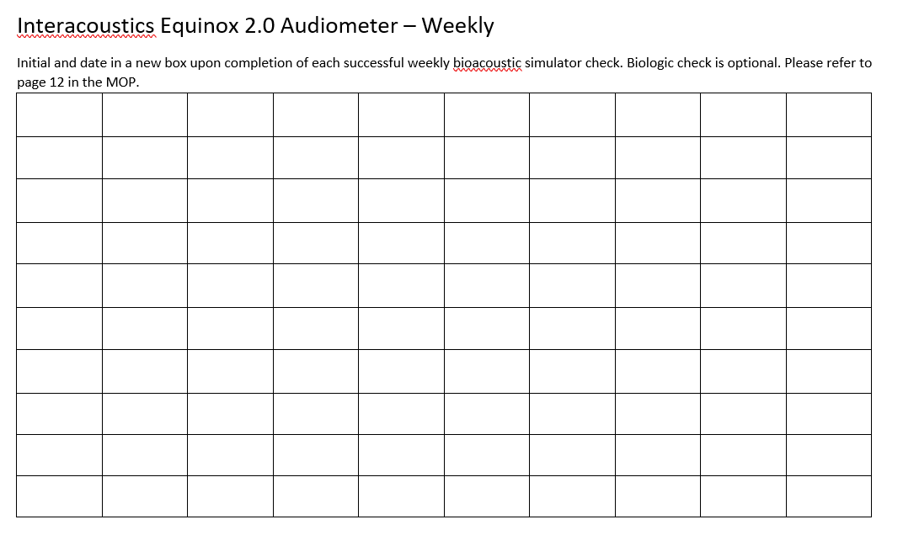
HearX Audiometer – Weekly
Initial and date in a new box upon completion of each successful weekly bioacoustics simulator check. Biologic check is optional. Please refer to Page XX in the MOP.

APPENDIX B: HEARX APPLICATION SET UP
1. Introduction
ARIC V12
Each participant will receive an audiometric exam via the hearTest audiometry app (hearX Group, South Africa) on a Samsung tablet.
Before beginning, team members will be thoroughly trained to perform testing. This manual, along with short video tutorials, will be made available to them for training purposes. The manual should be readily available during testing to ensure that if any questions come up, answers can easily be sought out.

2. hearX Application Set Up

Note: All devices will operate under the same account information. The account username and password has been sent via secure email to all team members.
2.1. Wi-Fi Connection
Prior to setting up an account, ensure device Wi-Fi connection.
Ensure your tablet is connected to wifi by tapping on the cursive i icon in the bottom left corner of the screen which will direct you to the tablet settings where you can add your wifi credentials.
Wi-Fi connection will be required while utilizing the hearX application set-up process and to transfer data to the cloud storage system, where they can be accessed by anyone who has permission. A Wi-Fi connection is not required during field testing after device set-up. However, Wi-Fi connection is required to upload all hearing test data to the cloud.
2.2. Open App and Enter Account Info
Open the hearX app (already installed) and the system will prompt the user to enter the account information (sent via email). Next the device will prompt the user to click ‘next’ to run the setup wizard.
2.3. Assign Device Licenses
A specific license will be made available to you by being bolded.
Tap on the lock icon in the top right corner and open the app menu by adding your Tester Password. In the Menu, scroll down to Licenses. Tap on Link. Your license will be highlighted. Tap on it in order to link it to the device. Tap on Done.
2.4. Link headphones.
Once the account is set up, headphones (HD 280 PRO Sennheiser) will need to be verified and linked to a Samsung device prior to any testing.
First, identify which headphone is for the right ear (red ‘R’), and for the left ear (blue ‘L’)

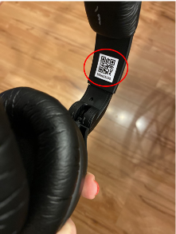
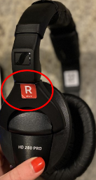
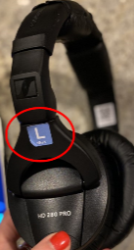

Second, In the Menu, scroll down to Headphones. Tap on Link. Identify the QR codes inside headband (above each headphone). Use Samsung device camera to hover over a QR code and automatically verify and link the headphones. Tap on Done. Note: only one QR code needs to be read.

2.5. Profile information
Please enter tester information in the profile which will then link test data stored on the device and cloud to the user. This will allow quality support for team members.

Device setup is now complete. The app will no longer prompt the user to run the setup wizard the next time the user opens the app for testing. The setup wizard can be run again in the future if needed.

2.6. Protocol
On the hearX app, click on the 'Lock' icon on the top right corner and enter the tester password.
On the side menu, click on 'Settings' and then on 'hearTest'.
Click on 'Manage Protocols' and then click on the '+' icon on the top right to customize the ARIC V12 protocol.
On the page, please name your protocol ARIC V12 and select the relevant frequencies needed for both right and left ears: 250 Hz, 500 Hz, 1000 Hz, 2000 Hz, 3000 Hz, 4000 Hz, 6000 Hz, and 8000 Hz. Then click on 'Save' at the bottom of the screen.

2.7. Headphone Verification:
Immediately following device setup, please complete these steps to ensure procedures run smoothly whether Wi-Fi is available or not. Testers will be able to successfully complete testing in rural areas.
- Click the lock icon in the upper right-hand corner of the home screen.
- Select Settings, and then select hearX.
- UNCHECK the box that says, “Daily headphone verification.”
- Select ‘SAVE’.
- Now, the headphones that were paired to the tablet will continue to be paired to that specific tablet (i.e., headphones can be unplugged, plugged back in, and still be paired without Wi-Fi).

REFERENCES
NHANES MANUAL (http://www.cdc.gov/nchs/data/nhanes/nhanes_09_10/audiometry_09.pdf)
CAOHC MANUAL (http://www.caohc.org/occupational-hearing-conservationist)

