

**When and How to Return the ARIC**

**ePatch Heart Monitoring Sensor AND the Continuous Glucose Monitoring Sensor**

You had **2** **sensors** placed on your body with your permission during your recent ARIC study visit.

|  |  |  |
| --- | --- | --- |
| An ePatch heart monitoring sensor was placed on your chest. | |  |
|  | A continuous glucose monitoring (CGM) sensor was placed on the back of your arm. | |

Your sensors were placed on ____________________(date).

ARIC staff will call and remind you to remove and return the ePatch Sensor and the CGM Sensor on ____________(date) in the morning / afternoon (circle one). During this call, staff will also ask you a small number of questions relating to this study.

Please do not remove the sensors until you have worn them for 14 days.

After 14 days, remove both sensors and use the mailer kit to return to the ARIC clinic. Instructions for removal and mailing are below.

**To remove the ePatch sensor**

1. A picture containing text, vector graphics

   Description automatically generatedPull up the edge of the patch.
2. Slowly peel away from your skin in one motion.

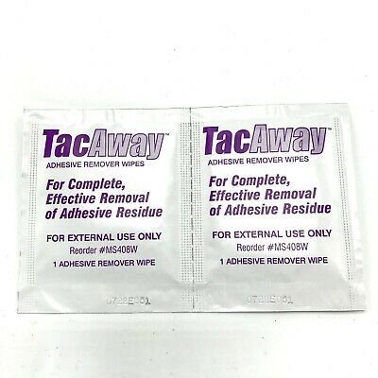**To remove the CGM sensor**

1. Wipe the area around the sensor on your arm with the Skin Tac-Away wipe.
2. Pull up the edge of the sensor.
3. Slowly peel away from your skin in one motion.

**Return Instructions**

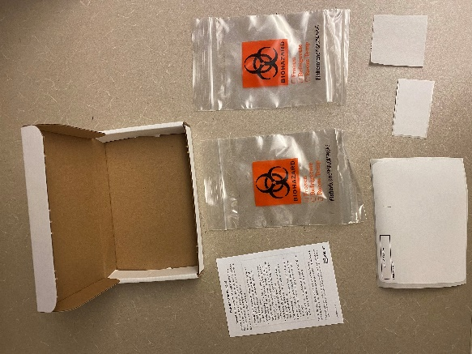

1. Fold the patch after removal to prevent the adhesive from sticking to the bag. Place the ePatch sensor and patch in the bag with the orange biohazard symbol, and the CGM sensor in the other biohazard bag.
2. Close the bag by pinching the zip top shut.
3. Place the closed biohazard bags in the padded envelope and close the sticky tape on the top. Both sensors should be placed in the same padded envelope.

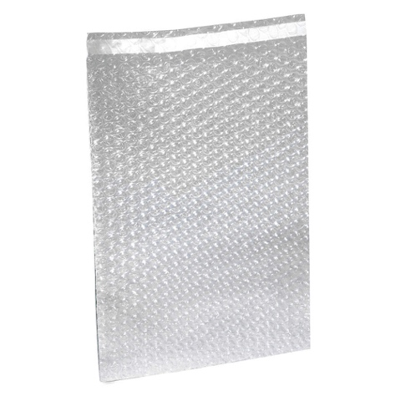

1. Place the closed padded envelope in the white box.
2. Close the white box by folding the flap down into the box and secure the box with the tape provided.

1. Drop the closed, taped box into the closest mailbox for return to the ARIC Center.

You may also return to the clinic to have a staff member remove the sensors if you prefer.

**To replace ePatch self-adhesive patch**

If the self-adhesive patch on the ePatch sensor comes loose or falls off before the end of the 14-day wear period, call the field center and set up a time for staff to replace the patch as soon possible. If you are unable to return to the field center, call the field center and staff can walk you through the following process. This only applies to the ePatch heart monitor, **not the CGM sensor on your arm**.

|  |  |  |  |
| --- | --- | --- | --- |
| 1. Follow instructions to remove sensor from self-adhesive patch. | | | |
|  | | | |
| 1. Remove new self-adhesive patch from the patch pouch. 2. Place the patch on a hard flat surface. |  | | |
| 1. Place the sensor into the patch and press down firmly to snap into place. You may hear several clicks while doing this.   **If connected properly, the sensor will show a constant green light for 15 seconds, followed by a flashing green light for 30 seconds. The recording will automatically start when the flashing green light stops.** | | | |
| 1. Locate patch placement template in the kit you were provided and follow instructions | |  | |
| 1. Remove clear backing from ePatch and apply to chest using template |  | | |
| 1. Press patch firmly onto the chest and remove the white paper from the top. | | |  |
| 1. If you have not yet done so, call your ARIC clinic to inform them that you have changed your ePatch adhesive and to clarify any questions that you may have. | | | |
|  | | | |

**More information about the**

**sensors you are wearing**

**What You Need to Know**

For this study, two sensors have been placed on your body.

An ePatch heart monitoring sensor has been placed on your chest. The sensor continually measures and stores information on your heart’s activity for up to 14 days.

A continuous glucose monitoring (CGM) sensor has been placed on the bottom of your upper arm. The sensor continually measures and stores your glucose levels for up to 14 days.

After you’ve worn the sensors for 14 days, we need you to remove them and place in the pre-paid mailer to be returned to the ARIC Clinic.

Once the devices are returned, we will be able to access and process the data. If you have told us that you want to receive your results, we will mail you a summary of your results. The summary will tell you about how your heart rate trended throughout the day and night during the time you wore the ePatch sensor and if any abnormal heartbeats were detected. It will also tell you about how your sugar trended throughout the day and night during the time you wore the CGM sensor.

**What You Need to Do**

* Wear the sensors for up to 14 days.
* If you already do self-monitoring of your blood glucose, continue regular blood glucose self-testing per your doctor’s recommendation.
* There’s no need for you to interact with the sensors. Just go about your daily routine.

**Showering, Bathing, and Swimming**

* Your sensors are water resistant, but not waterproof. They can be worn while exercising or showering, **but avoid spraying water directly onto the sensors.** We recommend that you face away from the shower head.
* **Do not swim or take baths while wearing these sensors.**

**Getting dressed**

* Use care to avoid catching the sensor on clothing while getting dressed.

**Security checkpoints**

* Notify security at airport checkpoints. There is a travel card for the ePatch sensor that you should bring with you at the end of this packet.

**Medical procedures**

* If you have an X-ray, MRI, a CT scan, or a diathermy (heat or ultrasound wave) treatment, you must remove your sensor prior to the procedure.
* If you need to have one of these procedures while you are wearing the device, please tell your healthcare provider.

**Removing the sensor**

* You will receive a call from the ARIC Clinic after 14 days to remind you to remove the sensors and provide instructions for removal if you need them.
* You may also return to the clinic to have a staff member remove the sensors if you prefer.
* Please do not remove the sensors until you have worn them for 14 days.

Removing the sensors is simple. Follow the instructions in this packet.

Note: Any remaining adhesive residue on the skin can be removed with the wipe that was provided, warm soapy water, baby oil, or isopropyl alcohol.

**If you have questions, please call the ARIC Clinic:**

[PHONE]

**Contact us if:**

• Either sensor becomes loose or is removed

• You have irritation or discomfort at either sensor site

• You have any questions about either sensor

**Travel Card (This only applies to the ePatch, and NOT the CGM)**

